- Purpose
  - The purpose of this document is to describe the procedure for final assembly on the Genesys Mid-Sized Scrubber, Disk Version.
- Scope
  - This SOP applies to all equipment assembly team members. The process applies to all machine ID’s:
- Responsibilities
  - The operations manager/supervisor is responsible for enforcing this SOP.
- Materials
  - The proper materials needed for this process are listed on the machine work order.
- Definitions

- Procedure
  - Place a frame and solution tank assembly (Roller) onto a build cart.
  - Install a set of 4 batteries (E28506 for wet batteries / E88031 for AGM batteries) into the tank.
  - Make 3 battery cable assemblies using a cable (E29203) and a red terminal cover (E12543). Wire up the batteries in series using the cables. Tighten to 8.5 ft-lbs torque. Ensure the positive and negative battery terminals are positioned as shown.

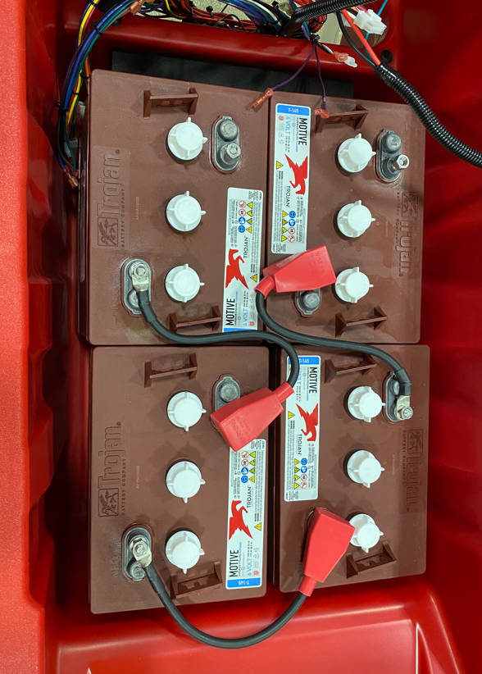
Front of
Machine
Operator
Side

  - Place a foam battery spacer (E28785) into place. Position it so that it is about 1” below tank edge.
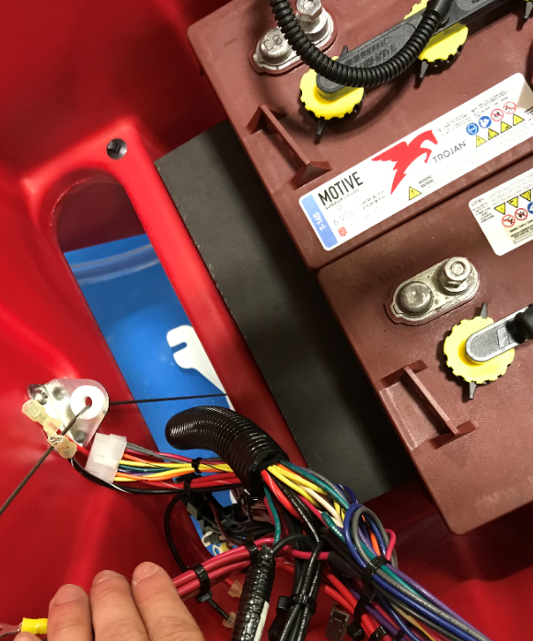
Position spacer about 1” below edge
  - Attach the end of the squeegee lift cable to the pivot. Thread a hex nut (E29565) up towards the top of the stud. Place a flat washer (E28617) over the threaded end and feed the stud through the hole on the squeegee mounting bracket. Then place a spherical washer (E28717) over the end of the stud and attach everything using another flat washer (E28617) and nut (E29565). Thread the nut up enough so that the assembly can still pivot properly.
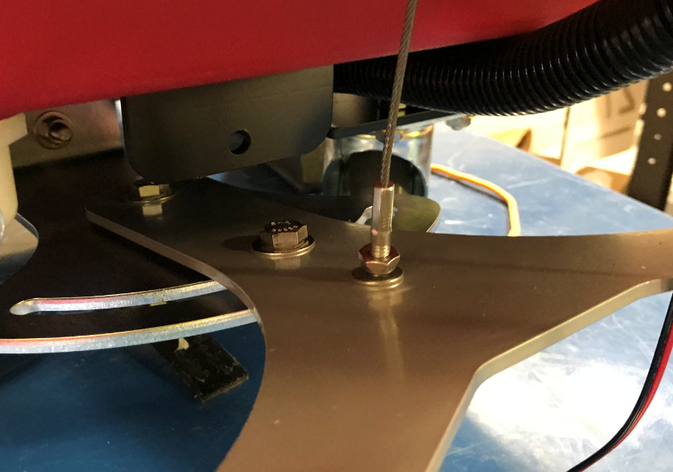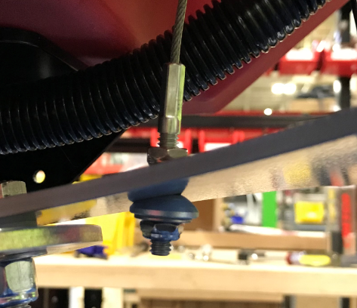

  - Take an Inner Electrical Panel (E28963). Add red loctite onto the standoff threads.

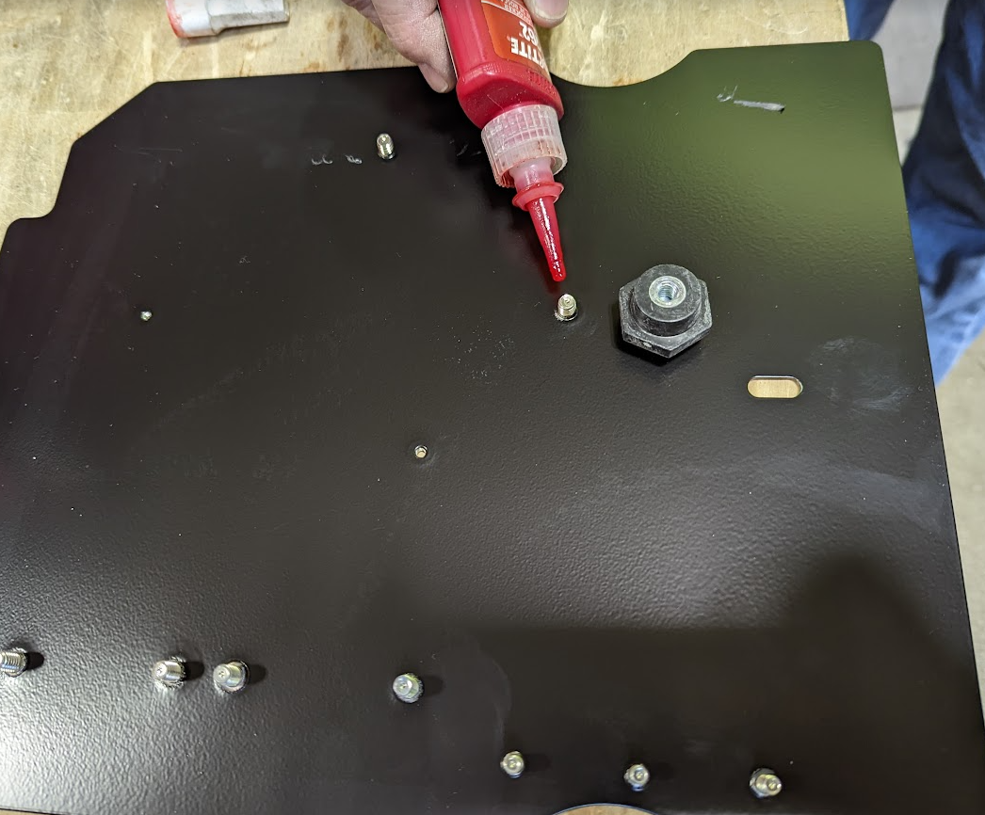

  - Attach an electrical standoff (E28950) to each stud and snug it in place. Be careful to not overtighten. Put some red Loctite onto a set screw (E29447) and thread it into the standoff. Repeat for the other standoff.

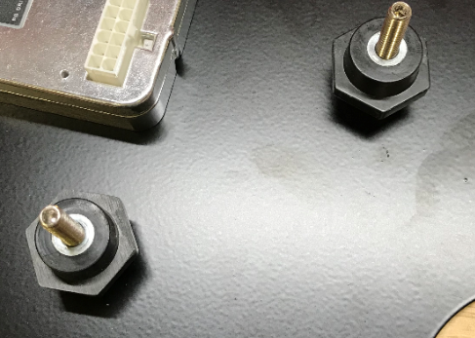
  - Mount the inner panel assembly to the solution tank using 2 screws (E28648) and 2 toothed washers (E29446). It will only fit in one direction as shown.
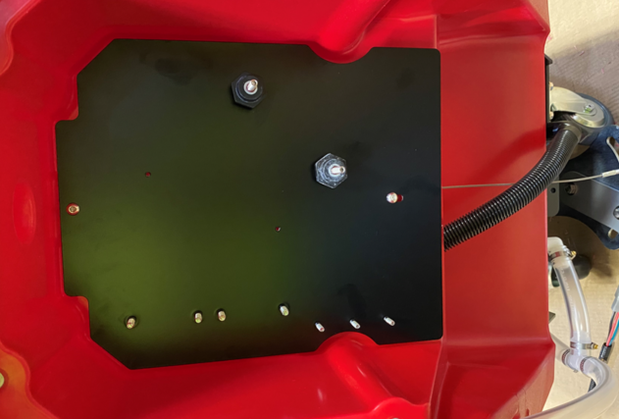
  - Hang the charger harness (E28979) ends to the appropriate panel standoffs. Note the location of the + and – wires.

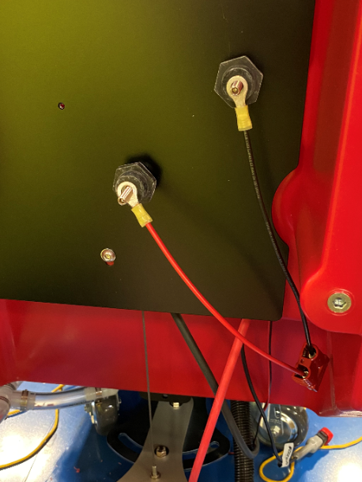
  - Pull the main wire harness back out of the back of the machine, then feed the portion of the main wiring harness that goes to the vac motor into the battery compartment as shown.

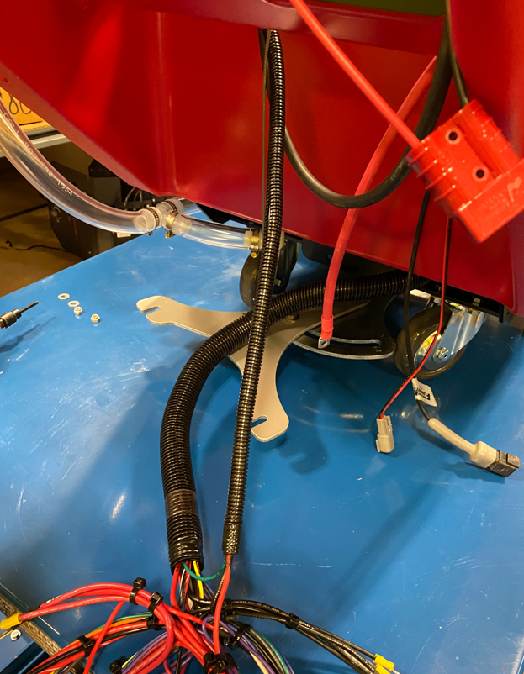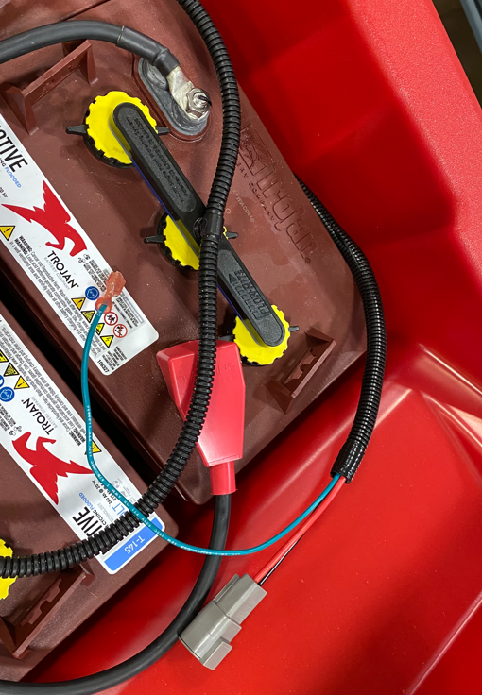

  - Take the 5” positive battery cable (E29204) and attach it to a fuse holder (E28974). Ensure the small hole on the cable goes to the fuse holder. Attach the other end of the fuse holder to another positive cable (E29202). Again, ensure the small hole on the cable goes to the fuse holder. Install the fuse (E28975) into the holder, tighten the nuts, and snap the cover in place. Finally, put a terminal cover (E12543) over the ends of the 5” cable.
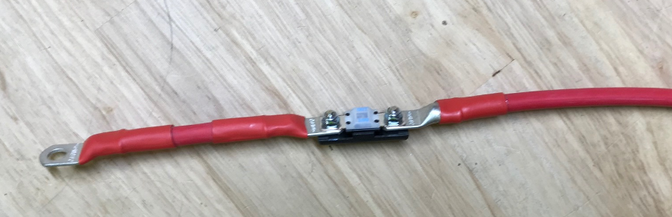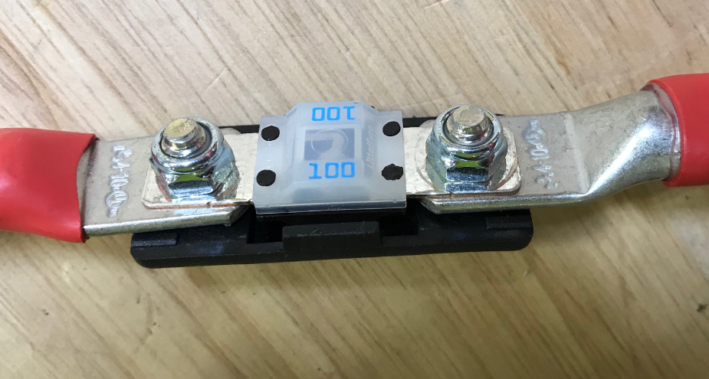
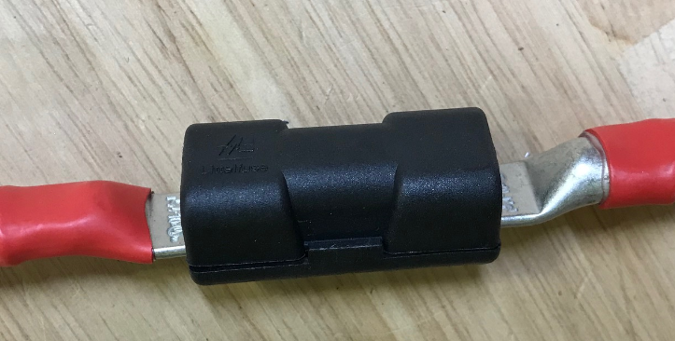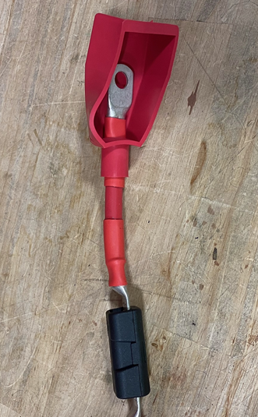
  - Hang the positive battery cable that was just assembled to the positive panel standoff. Use the end furthest from the fuse. Feed the other end into the battery compartment, but to not attach it. Place it beside the batteries so it does not inadvertently touch a terminal.
  - Hang the negative battery cable (E29201) to the negative panel standoff. Attach the end of the cable with the small hole. The other end can be routed into the battery compartment and attached to the proper negative terminal.

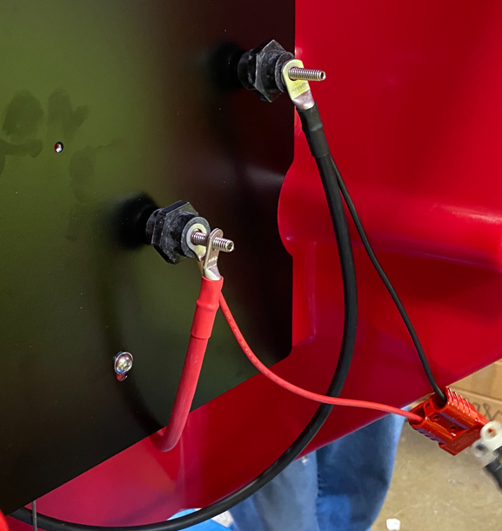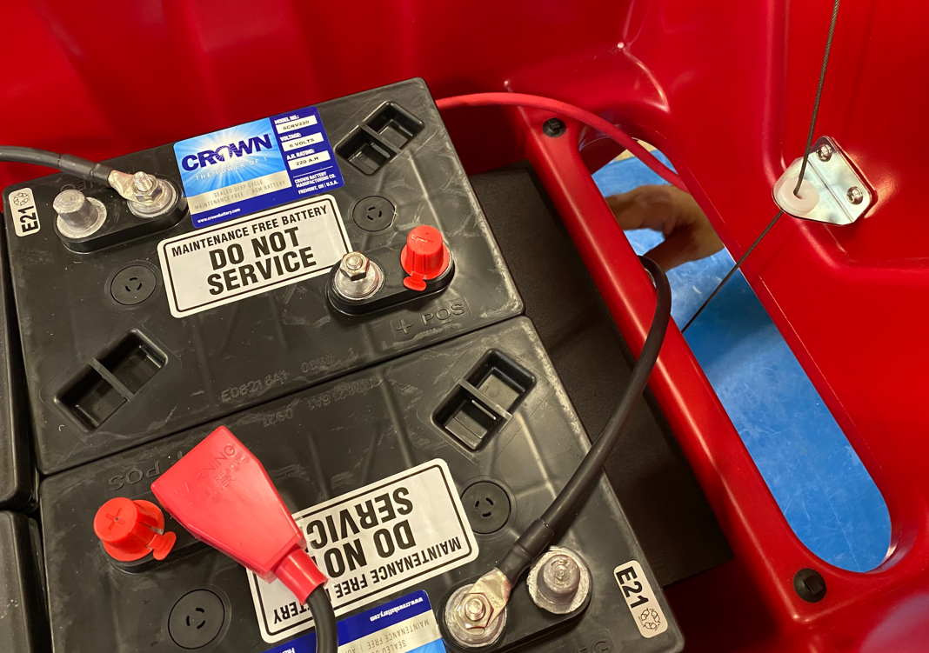
(+) unattached
(-) attached

  - Attach the + and – terminals from the main harness to the appropriate standoffs on the panel. Fan the terminals out so that they tighten up properly. Unless there are options on the machine, the nuts on the studs can be tightened. Use a nut (E28853) and a washer (E28617) on each one. Use a torque wrench to tighten to 8 ft-lbs. Tug on the wires to ensure they do not move. When using the torque wrench, only hold on the handle as shown to get an accurate reading.

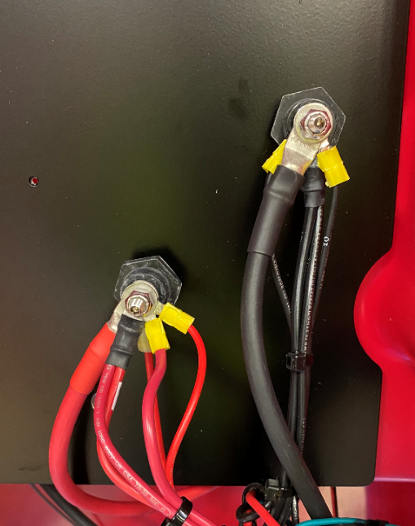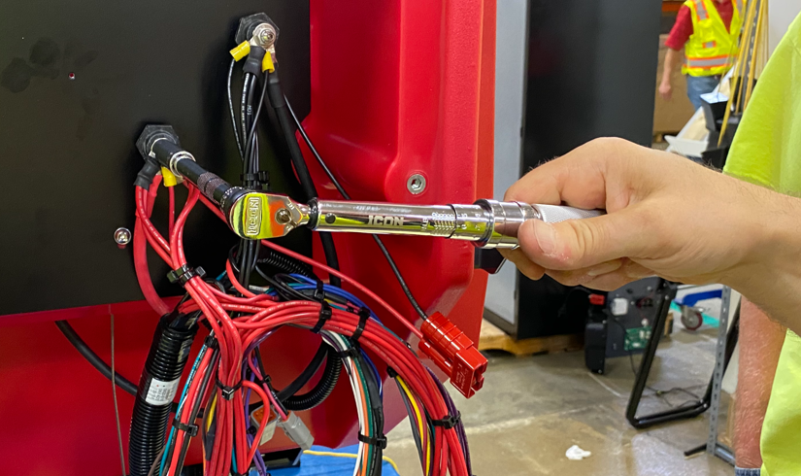
  - Mount the relays from the main harness to the appropriate studs on the panel with hex nuts (E29366). Ensure they are tight. The smaller relay goes on top.

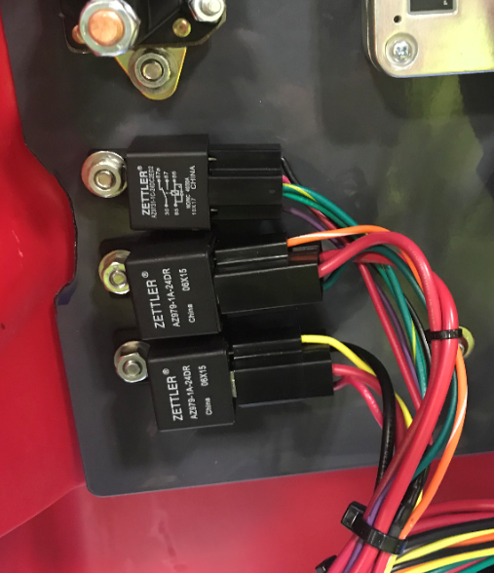

  - Connect the appropriate connectors on the main harness to a Contactor (E28924). The hardware is already on the contactor. There are 2 contactors on the disk machine. The order of the wires in not critical but to be consistent, place the yellow on top as shown. Use a ratchet/nut driver to ensure the nuts are fully tightened. Mount the contactor to the panel using 2 nuts (E28618). Pull on the wires to make sure they don’t move.
Wire Numbers
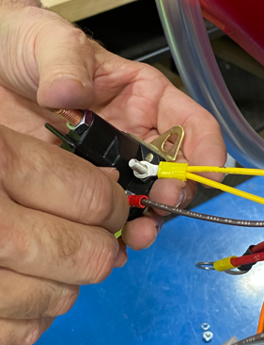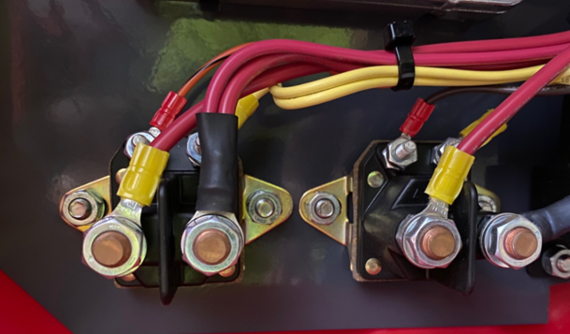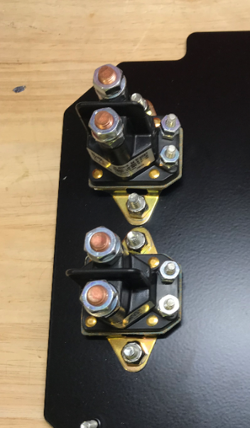
12&12/82A
4A&4B
2E
2F
22&22/82
31
4&4A
33
  - Connect the appropriate connectors on the main harness to the I-Drive (E28949). There are 4 single wires, a 2 pin connector, and a 14 pin connector. Note the labels and locations below.
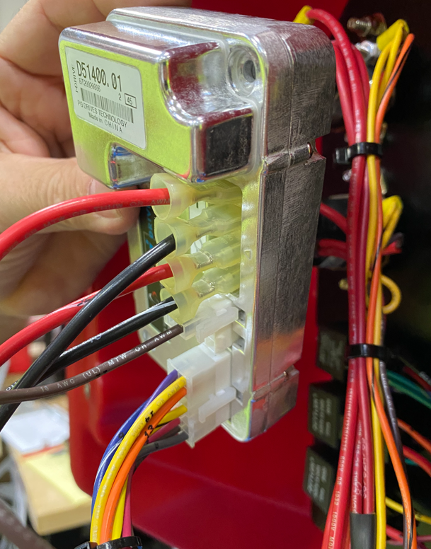
2 pin connector with single brown wire
14 pin connector
42
10D
52
70
  - Attach the I-Drive to the panel using 2 Pan Head Screws (E29382).

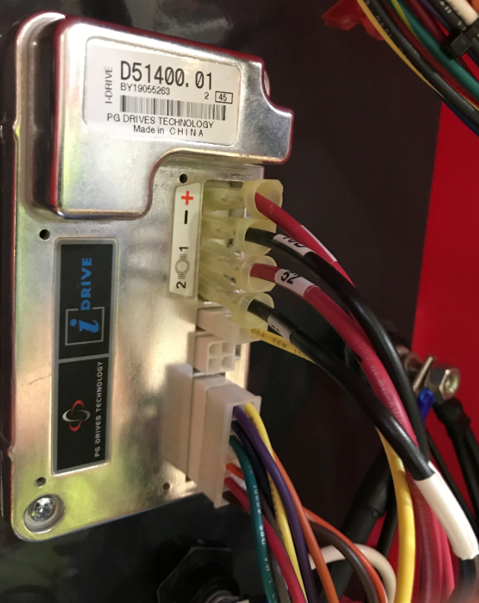

  - Feed the wires for the handle console/bail through the holes and into the upper cavity.
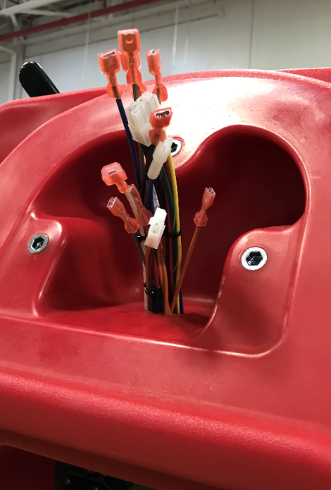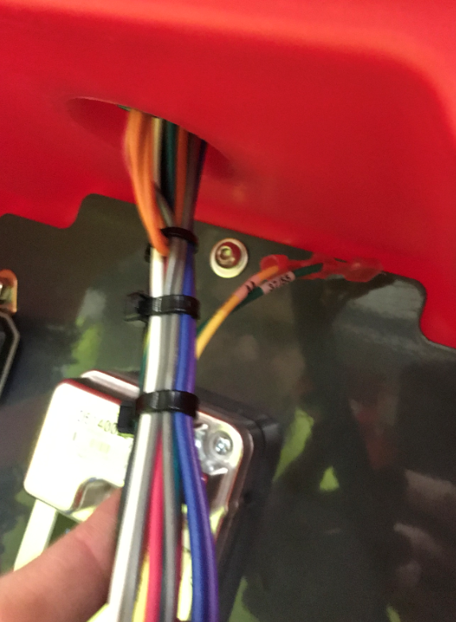
These 2 wires always stay in the lower compartment
  - Take a bail assembly (See the appropriate SOP for assembly instructions) and connect the microswitches to the appropriate wires from the main harness up in the handle attach area of the tank. The photo shows the correct sequence. Wire numbers are noted in the photo.
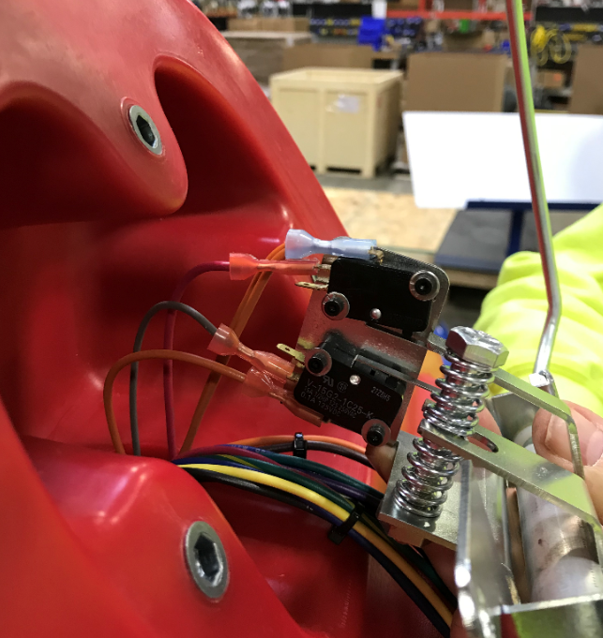
8
63A
62
63&63A
  - Attach the bail assembly to the solution tank using 2 bolts (E81089) and 2 washers (E81062). Ensure the wires are coming out of the appropriate side of the bracket as shown.

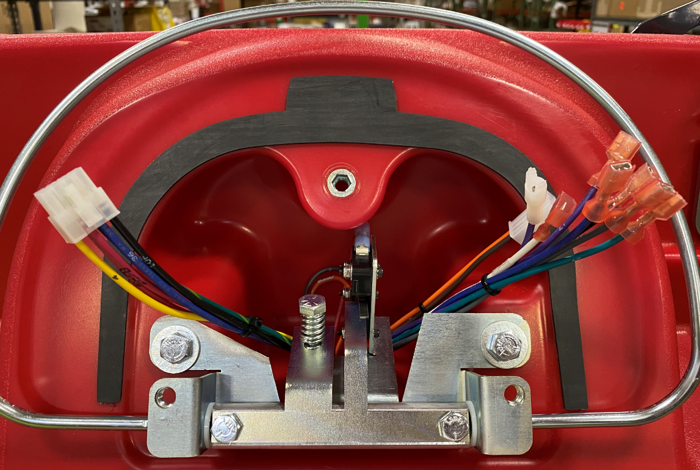

  - Get a handle assembly. See the appropriate SOP for assembly instructions. Connect the potentiometer from the handle to the appropriate terminal on the main harness.
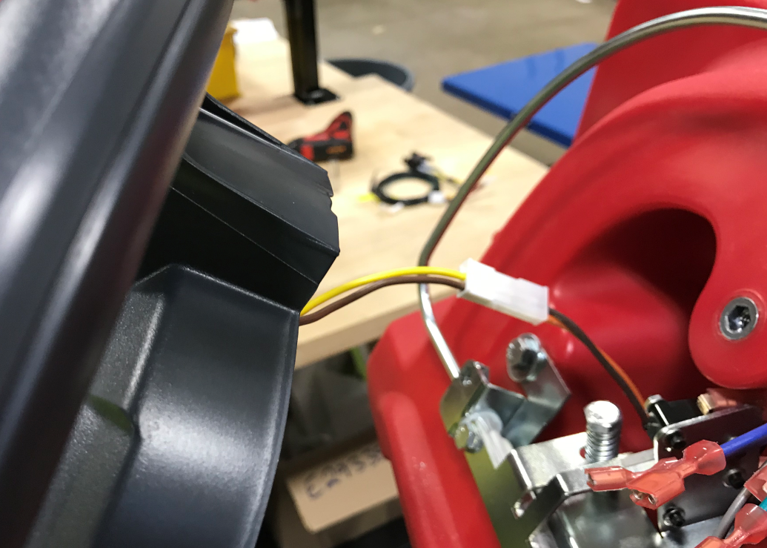
  - Fasten the plastic handle to the tank using 3 bolts (E81089) and 3 washers (E81062). Use Blue Loctite on the bolts. Make sure to not pinch any of the wires on the harness.

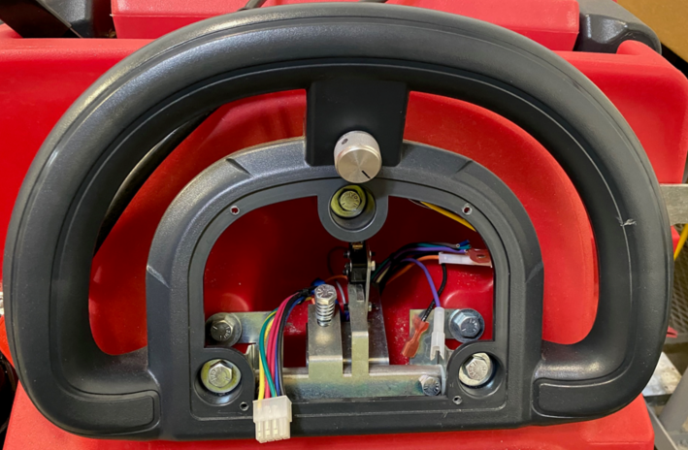

  - Take an appropriate console panel (See SOP for Assembly Instructions).
  - Connect the 8-pin connector from the main harness into the BDI. Verify the BDI has the proper setting for the battery type. It should be set at “1” for wet batteries. If the machine has AGM batteries, change the arrow to “4”.
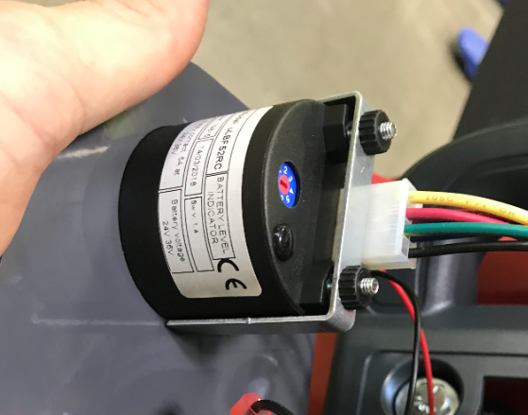
  - If the machine is equipped with SOliChem, connect the two wires from the Solichem LED to the main harness. These connectors are error proofed. The wire numbers from the harness are shown.

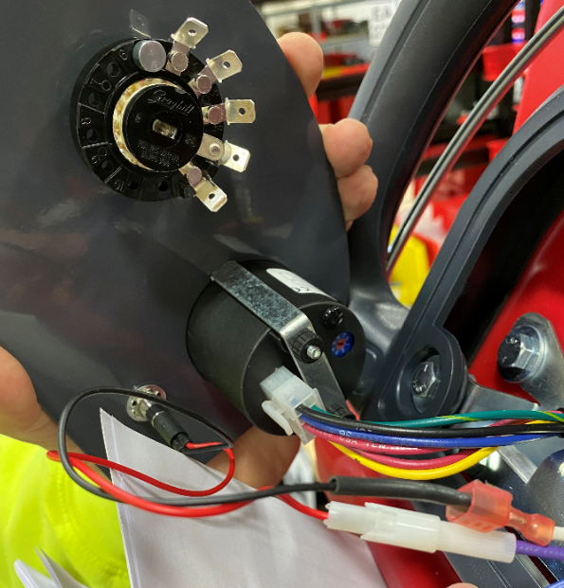
Purple-65A
White-71

  - Connect the appropriate wires from the main harness to the down pressure switch. See the photo for the wiring sequence.

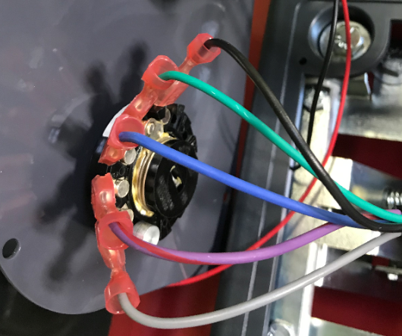
28
27
26
25
10B

  - Mount the console panel to the handle using 4 screws (E29334). Tighten by hand and be sure not to overtighten or the decal will wrinkle. Pull on the knob to make sure the panel doesn’t move.

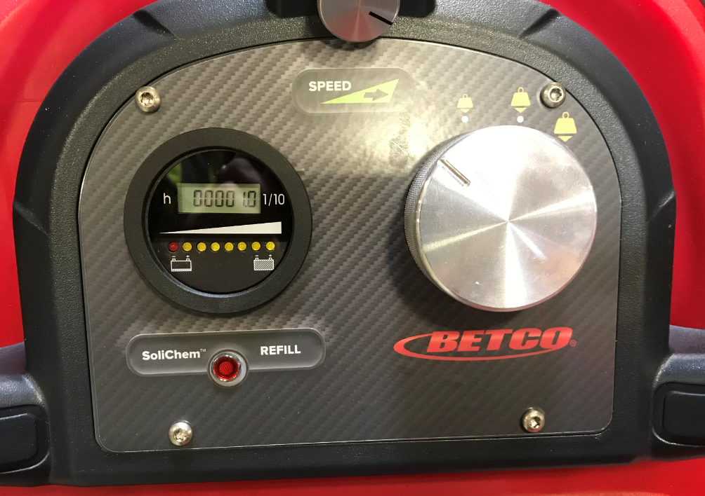

  - Get an outer electrical panel (Refer to the appropriate SOP for assembly instructions). If the machine is getting AGM batteries, the dip switch settings need changed. Peel back the label on the charger. For SW1, both DP1 and DP2 need to be OFF. Both switches should also be OFF for SW2.
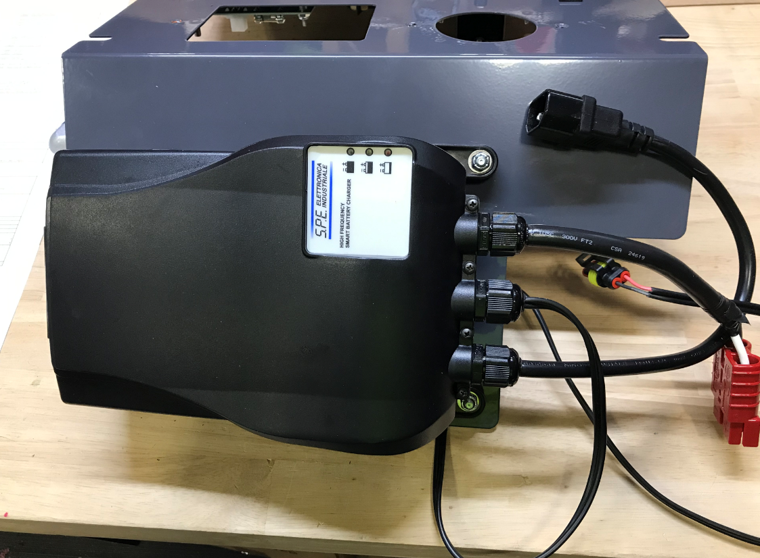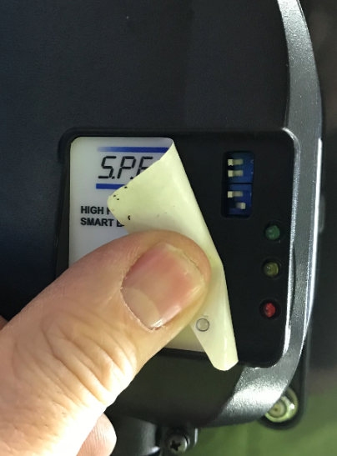
SW1
SW2
  - Connect the appropriate connectors from the main harness to the circuit breakers on the panel. An orbital machine will only have 3 breakers. There are 4 pairs of 2 wires for a disc machine. The lengths and/or how they are held by the wire ties should give the order. If not, use the wire numbers shown below. Right or left terminal does not matter. If wires 22 & 22A seem too short, cut the zip tie that holds them. This should give them enough slack to connect.
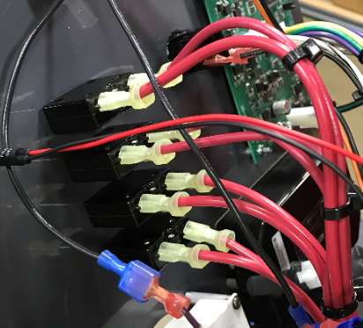
21 & 42
32 & 32A
12 & 12A
22 & 22A
  - If the machine has SoliChem, connect the appropriate connectors from the main harness to the TDS Switch. It does not matter which switch goes to which terminal.

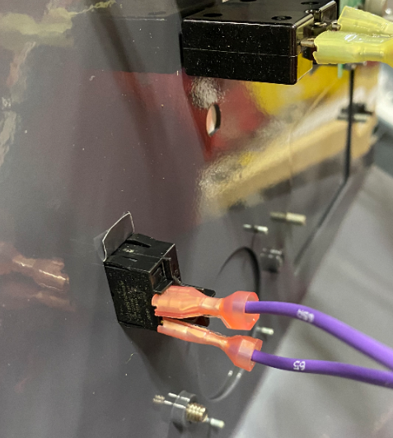
65 & 65A

  - Connect the Key Switch to the main harness. It does not matter which wire goes to which terminal.
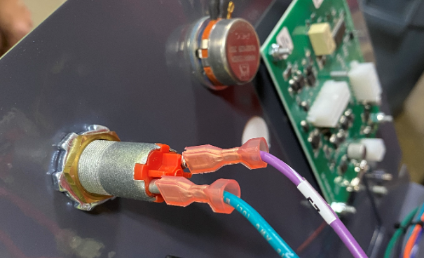
5/15/57
57
  - Connect the solution potentiometer to the appropriate connector on the main harness. It is a 2 pin connector.
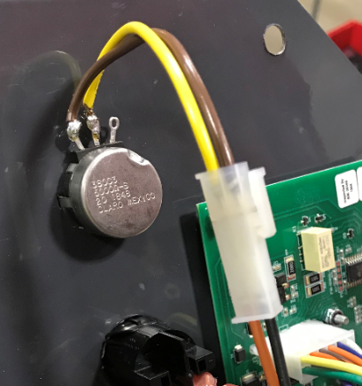
23
10R

  - Connect the appropriate connectors from the main harness to the control board. There are 3 terminal blocks to plug in (12 pin, 10 pin, and a 4 pin).

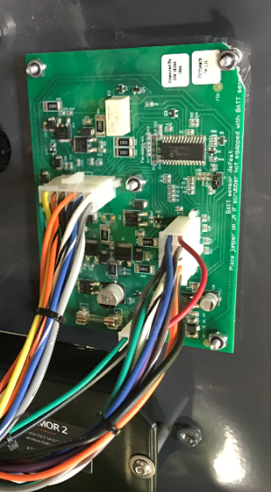

  - Connect the pad release button to the appropriate connectors on the main harness. It does not matter which terminal goes to which wire.
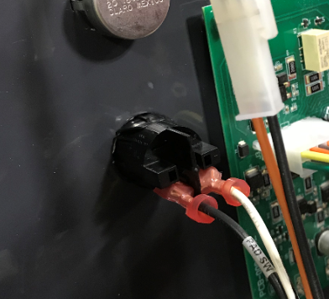
29
10C
  - Connect the Andersen connector from the charger to the charger harness that was mounted to the inner panel.

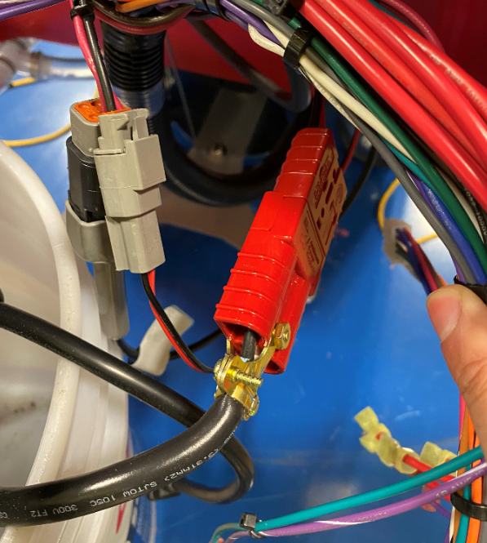

  - Connect the charger interrupt connector from the charger to the appropriate connector on the main harness.

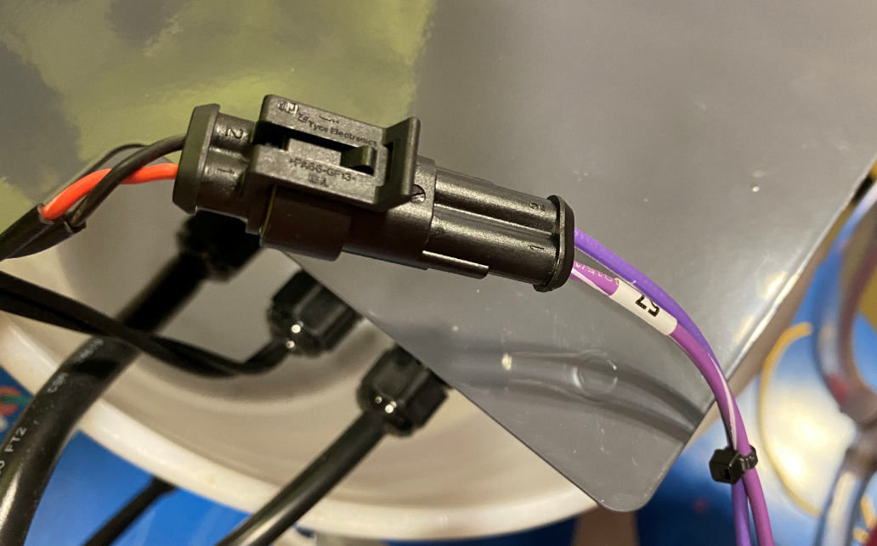

  - If the Wet Battery Protection Option is needed. Refer to section 6.01 in SOP EQ 111 (Genesys MSS Final Assembly Options).

  - Mount the panel to the tank using 4 washers (E28617) and 4 screws (E28648). Be careful as they can strip. Make sure all wires are tucked inside on the cavity and don’t get pinched. The main portion of the harness should pass through the cutout in the panel.

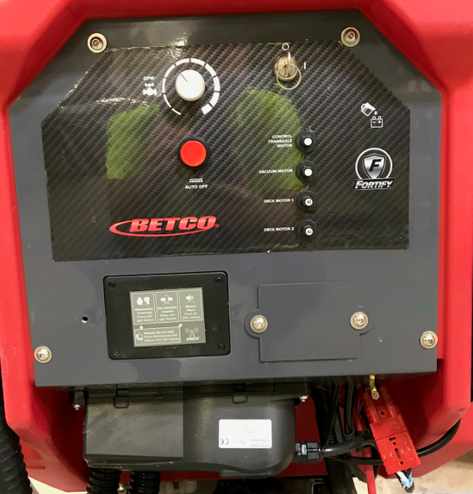
Main Harness should pass through here

  - Connect the charger extension cord (E28704) to the charger and wrap the excess around the cord wrap.
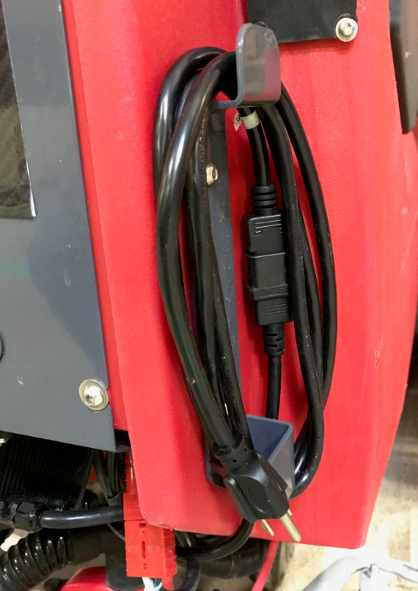

  - Mount the appropriate sized squeegee assembly to the machine. See the required SOP for assembly instructions. (35” squeegee for a 26” machine / 40” squeegee for a 28” machine / 45” squeegee for a 32” machine). Mounting the squeegee will also help keep it from rolling.

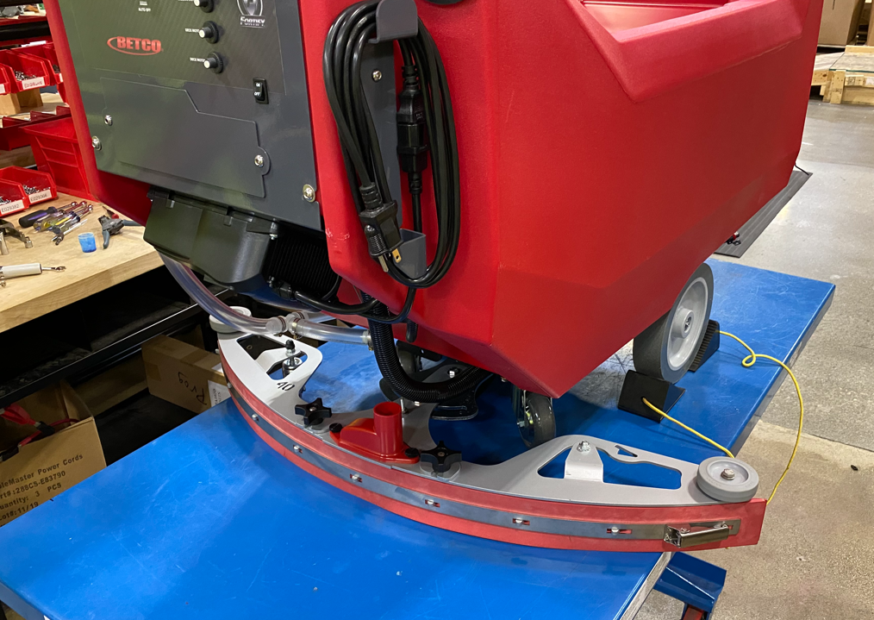

  - Ensure the key is in the “OFF” position. Connect the main positive battery cable to the battery terminal. Verify that the BDI comes on. If it does not, there is an issue that you need to troubleshoot before moving on.

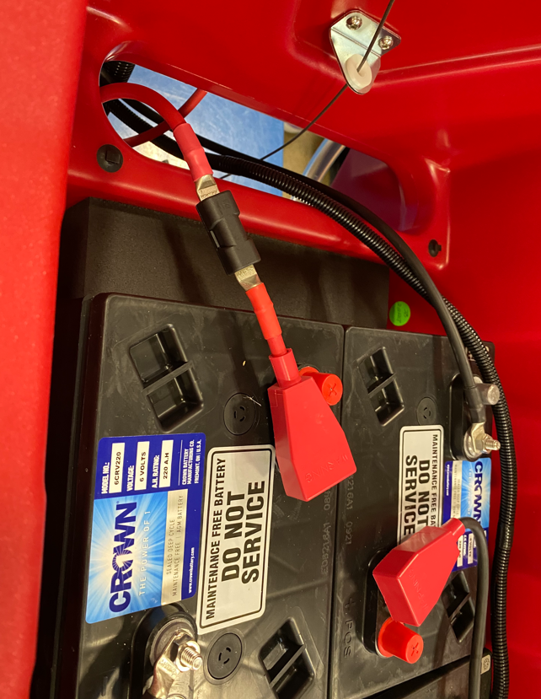

  - Attach the roller track bracket to the solution tank using 4 hex bolts (E81089) and 4 flat washers (E28622). Use blue Loctite on the threads. The plate can be allowed to hang low on the slots.

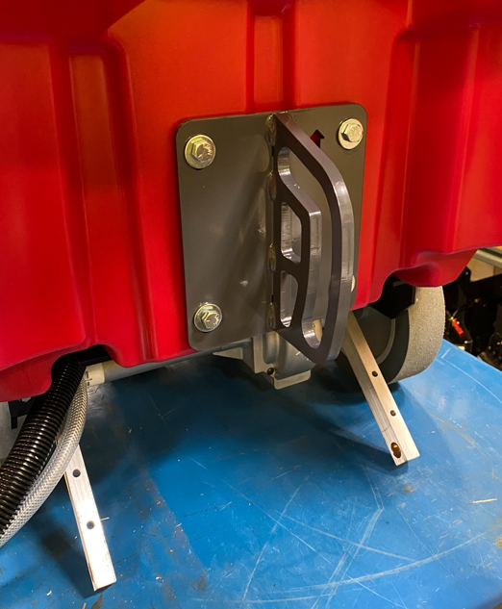

  - Place the appropriate sized scrub deck onto the table in front of the machine. Refer to the proper SOP for scrub deck assembly instructions. Feed the solution hose and the wire harness coming from the frame through the area shown.

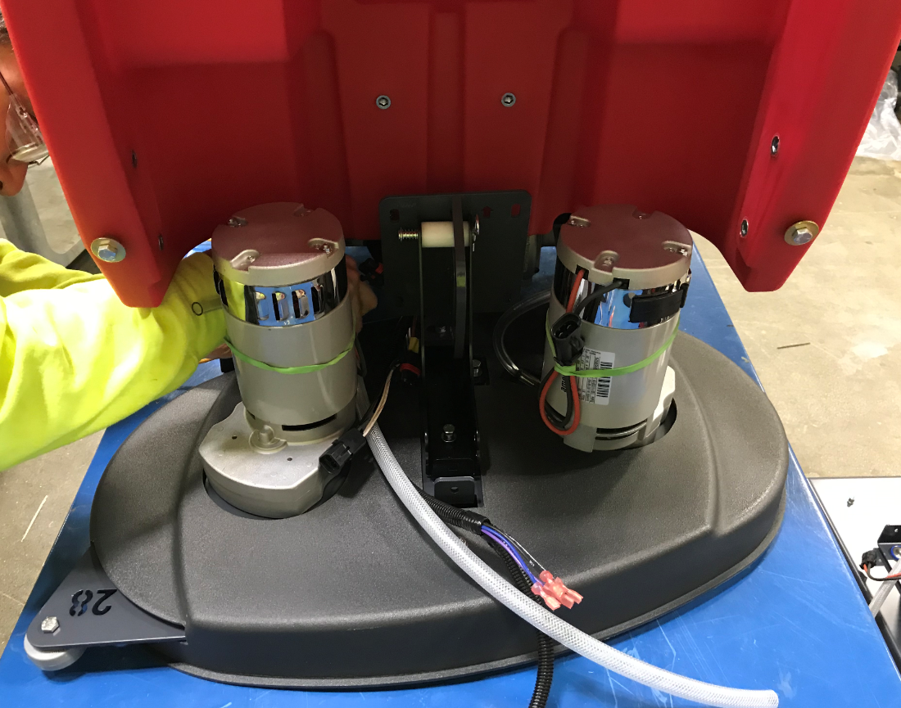
  - Take a 1” roller (E28663) and install a roller bushing (E28664) into it.

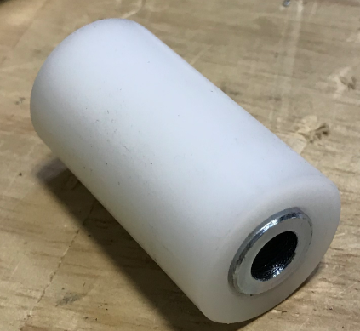

  - Take a clevis pin (E28783) and place a washer (E28622) and a spring (E29328) over it.

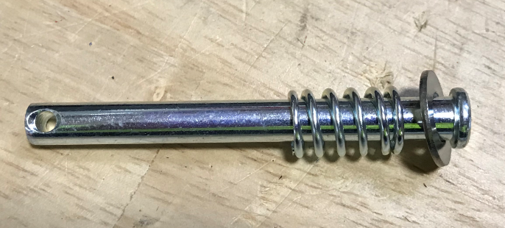

  - Line the roller bracket on the head with the roller track bracket on the tank. Place the roller between the uprights on the roller bracket and in line with the holes. Insert the pin through the bracket and the roller. Compress the spring to expose the end of the pin and install a washer (E28622) and a cotter pin (E28671) to secure it.

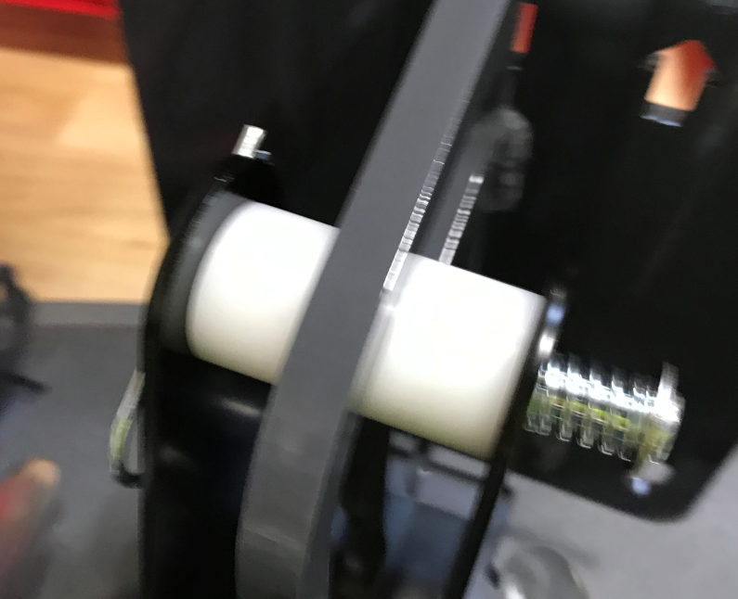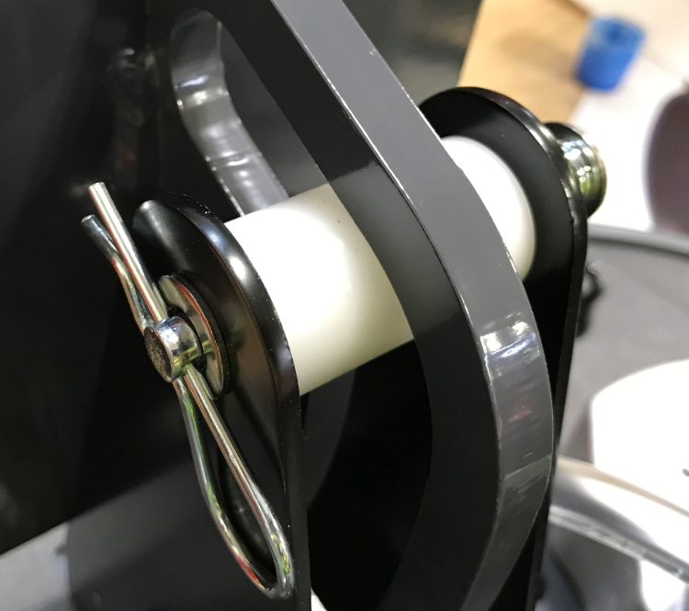
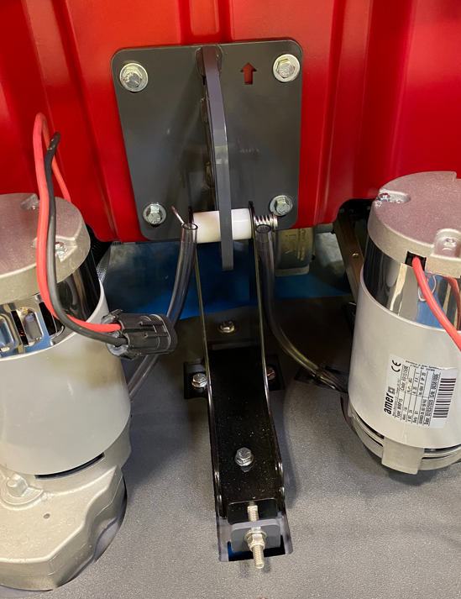

  - Attach the disk head assembly to the lower frame using 2 clevis pins (E28697) and 2 cotter pins (E28671). This connects the frame arms to the disk head brackets.
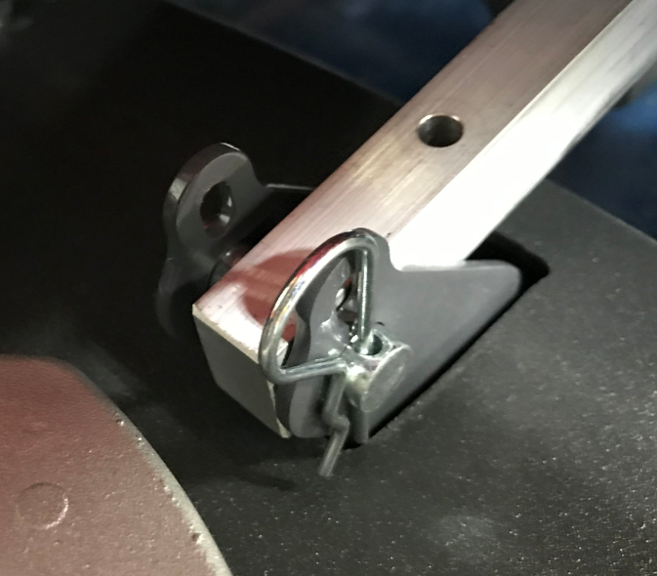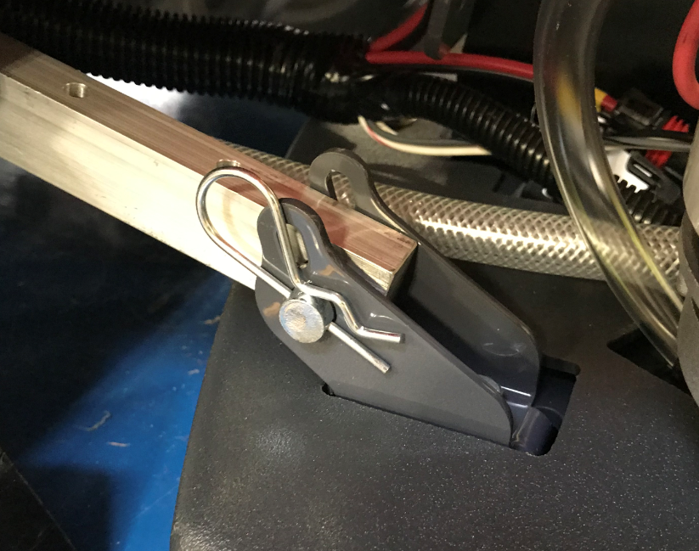
  - Gently tighten the 3 bolts that hold the roller track bracket in place. Then tighten the carriage bolt on the end.

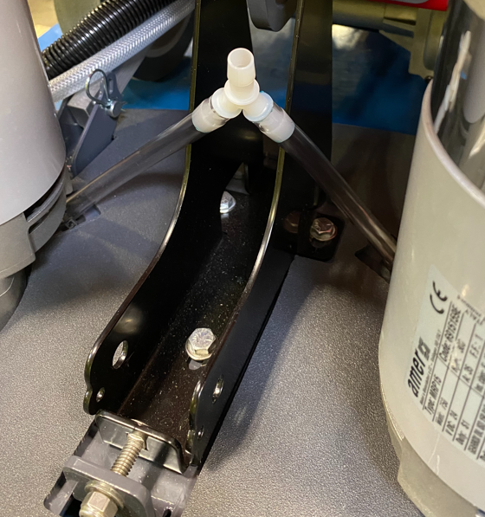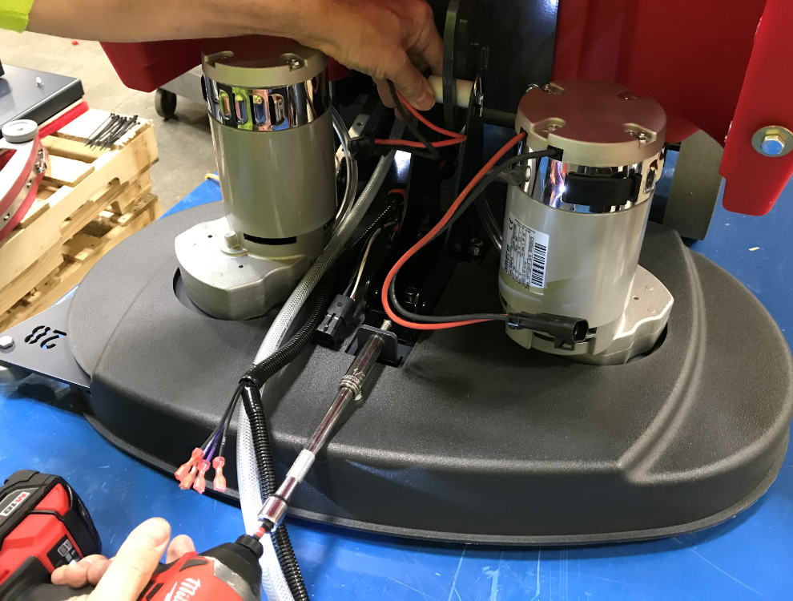

  - Get a y-fitting (E28747) and see where it will sit based on the current solution hose lengths. There may be extra hose that can be trimmed. Position this so that the fitting sits centered above the bracket. Trim to hoses so that there is no stress on the fitting from the bracket but not so long that it will sag. Ensure there are no kinks where the hose goes into the deck.

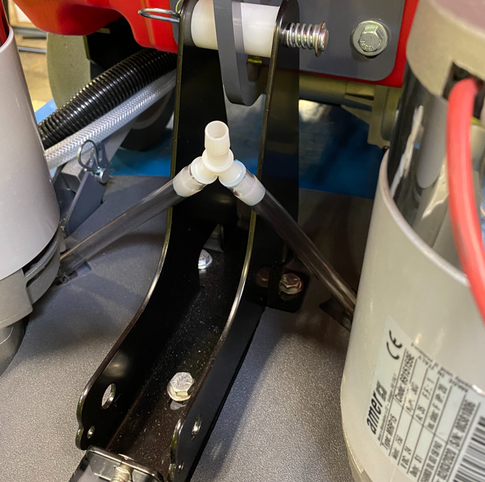
Hoses are not stressed against the bracket edges
Centered on bracket

  - Plug the brush motors into the appropriate harness terminals. Note the right and left wires. The connector with the yellow tape goes to the motor on the assemblers right side (Operators left) (Wires 12A and 10H).
  - Use a zip tie (E88890) to bundle the wires and hoses as shown. Note that the wire for the motor on the operators right side is folded over. Trim the zip tie when tight.

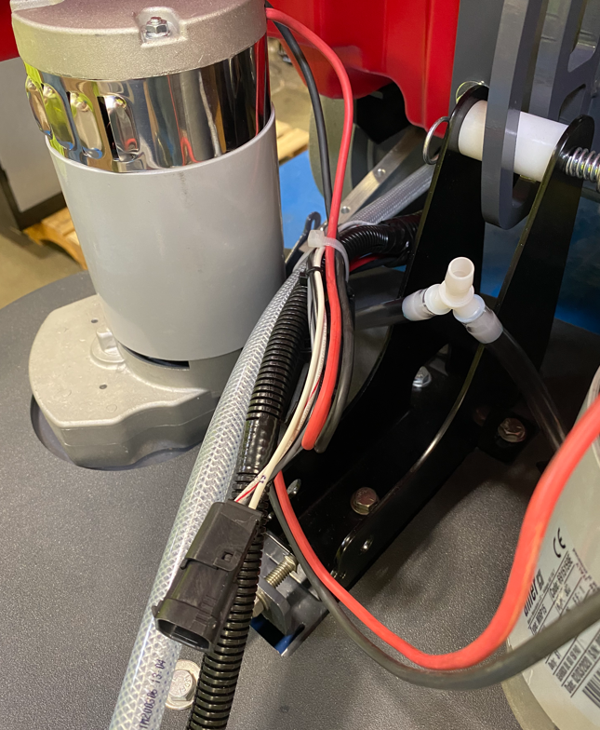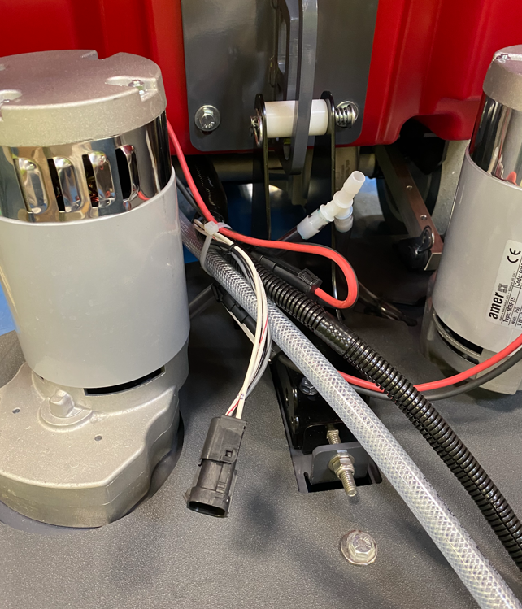

  - Get a head lift assembly equipped and a head lift support bracket (E20702). (Refer to the appropriate SOP for head lift assembly instructions) Insert the support bracket into the bracket as shown. The slotted holes in the bracket will align with the ones on the head lift.

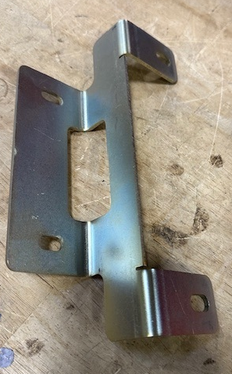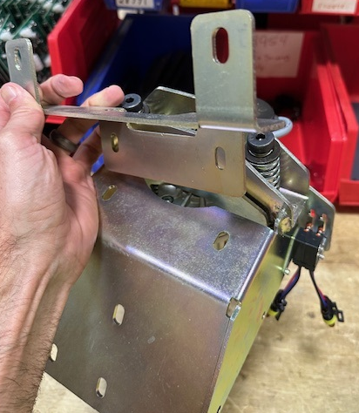
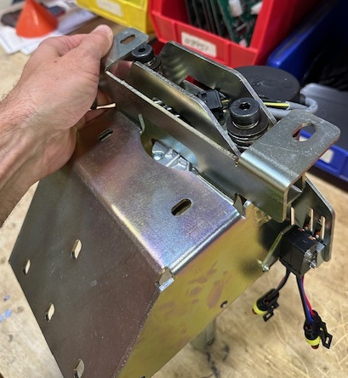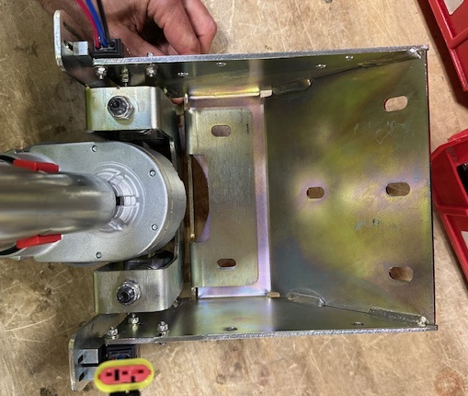
  - Attach it to the solution tank using 4 bolts (E81089) and 4 washers (E28622). Use blue Loctite on the bolts. Tighten them all evenly so that the assembly locates properly against the tank.

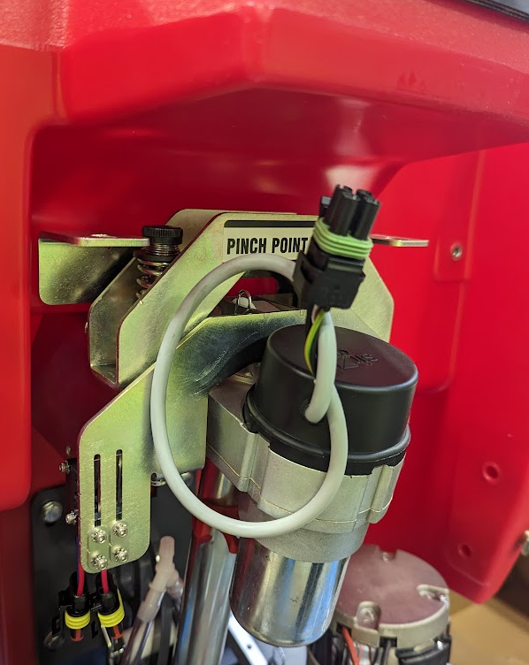

*Note: Slide head lift support bracket as flush to the tank as possible to minimize the gap between the bracket and tank.
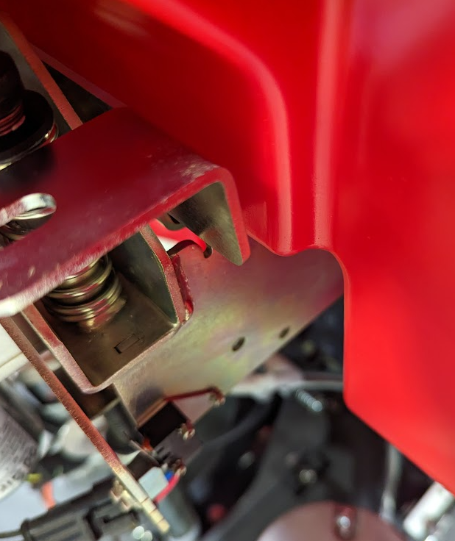

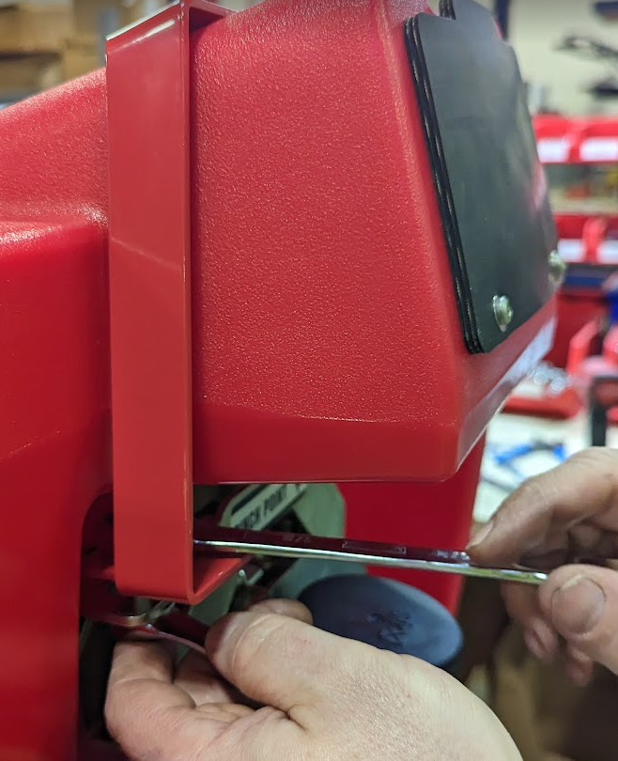
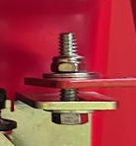
  - Add a red support strap (E20703) above the front fill port. Attach the support strap using 2 bolts (E10112), 4 washers (E081062) and 2 nuts (E28623) using a ½” wrench.
Washers (2)
*Note: Tighten the bolts so they are snug, but not too tight. Do not draw the bracket and strap plates together.
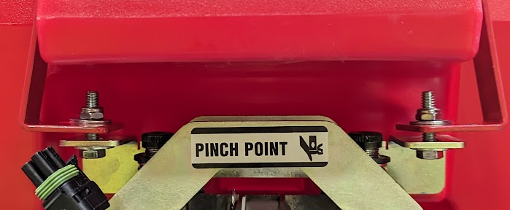

  - Connect the cable for the actuator to the cable on the power supply. Turn the power supply on.

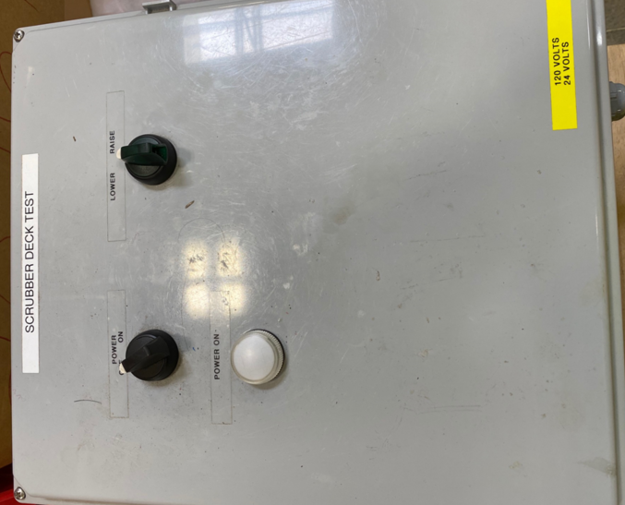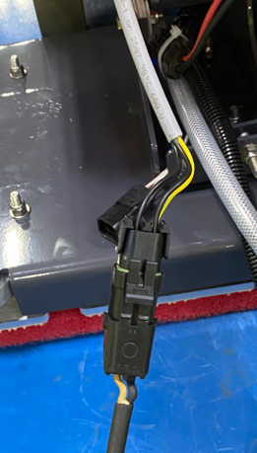

  - Remove the red clip from the actuator. Do not spin the actuator sleeve by hand. Hold the actuator sleeve stationary (so it doesn’t rotate) and turn the knob on the power supply to the “Lower” position. This will lower the end of the arm to the deck. Fine adjust it when it gets close so that the hole in the actuator shaft lines up with the hole in the bracket.

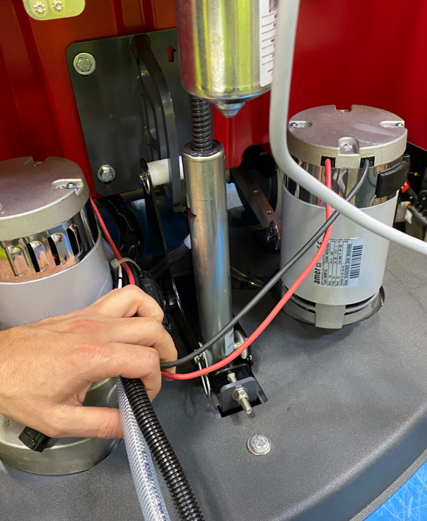
Holes line up

  - Place 2 plastic washers (E83145) on each side of the actuator arm. Install a clevis pin (E28699) to connect the actuator arm to the deck. Secure it with a cotter pin (E28671). You may need to squeegee the bracket together to get the pin installed.

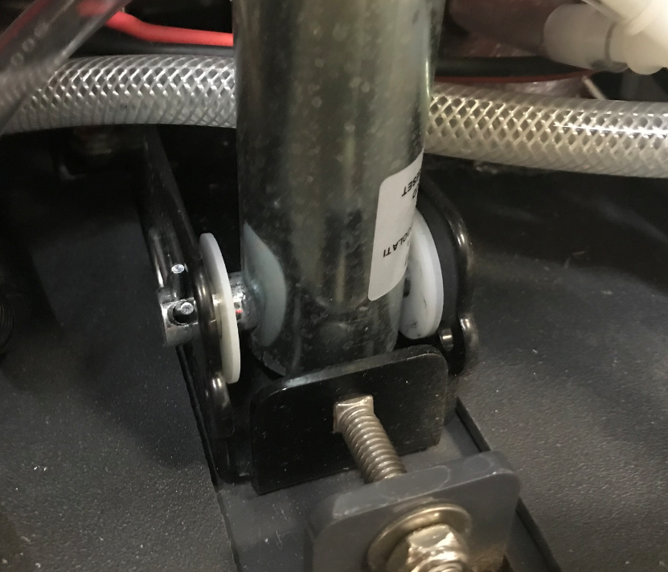

  - Manually cycle the deck up and down to make sure everything moves properly.
  - If the machine is equipped with a Solichem system, get an assembled solution canister and a puck cage. Place the puck cage into the canister. Refer to the appropriate SOP for assembly instructions.
  - Attach the tube to the machine using 2 loop clamps (E28969), 2 screws (E28648), and 2 washers (E28617). Line it up so that the top cap is just above the upper clamp. This will ensure that the lid does not interfere when it is closed. Tighten the screws with care so not to strip the inserts.

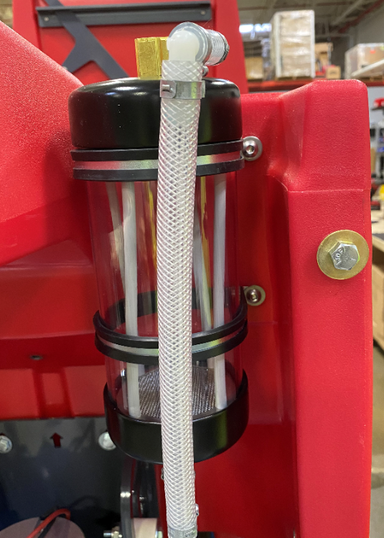

  - Hold the supply hose from the pump up to the t-fitting on the solution canister assembly. Try to match the slope with the hose in the photo. You may need to trim about 1” off of the end. Before connecting to the fitting, place a pinch clamp (E28773) onto the hose. Once it is positioned properly, pinch it to secure.

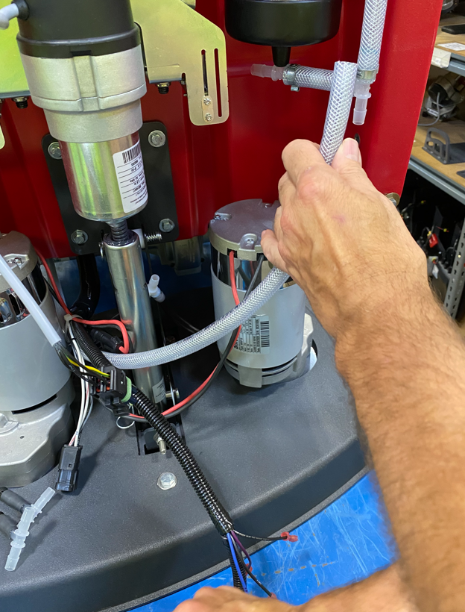

  - Cut a 12” piece of 3/8” hose (E28620). Press one end of the hose onto the Y-Fitting on the scrub deck. The other end goes to the outlet port of the solution canister. Make the slope match the photo below. You may need to trim some. The y-fitting should still sit vertically.

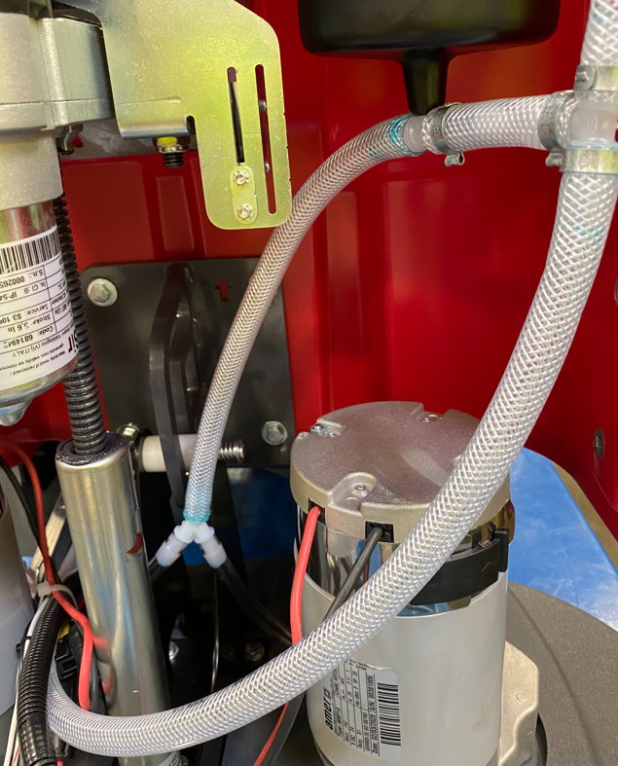
  - Get a TDS Board assembly and 2 conductivity probes. Refer to the proper SOP for how to build these.

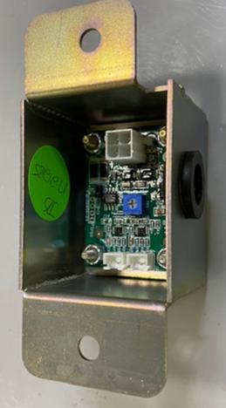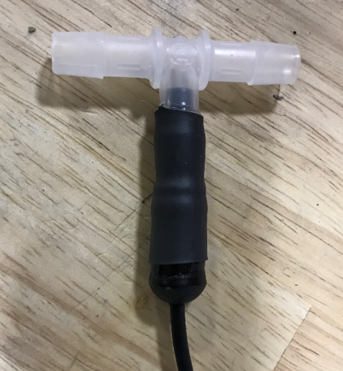

  - Install one of the probes into the feed line going from the canister to the deck. Cut the hose about 5”-6” from the canister and install. This will ensure the probe is close to the horizontal portion of the hose yet away from the motor when the deck is raised. Point the body of the probe towards the back of the machine as shown.

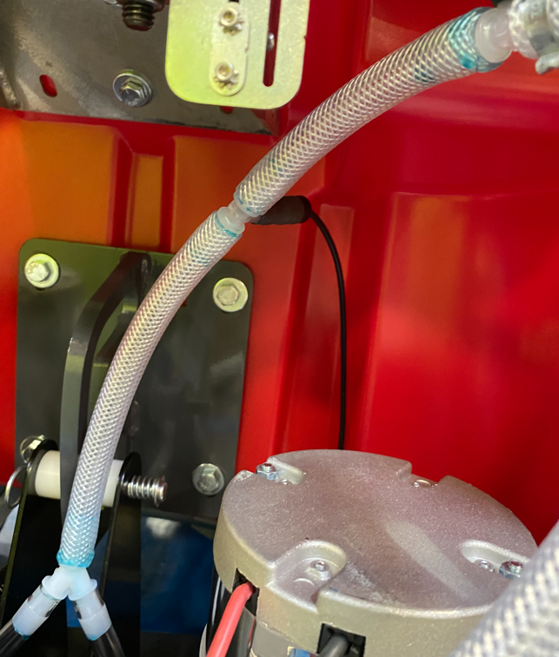

  - Install the probe into the supply line from the pump. The probe needs to be pointing upwards as best as possible. Cut into the supply line close to the deck where the hose flattens out. This will be about 8”-9” from the canister. Install the ends of the T into each hose with a pinch clamp (E28773) over each. Orient the probe as shown in the photo to make sure it will not hit anything as the deck goes up and down. Pinch the clamps once it is oriented properly.
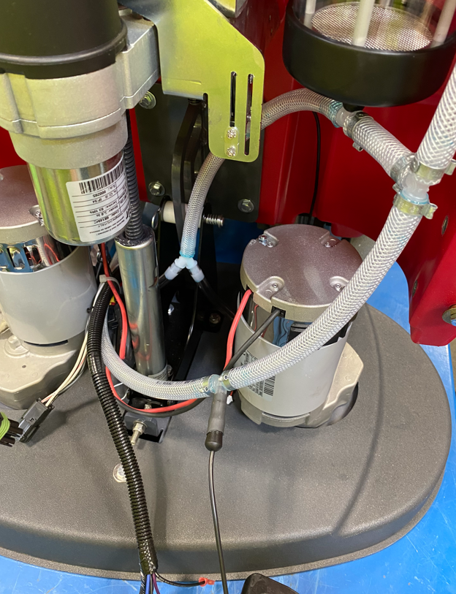
  - Pop the rubber grommet out of the TDS box and pass the 4 pin terminal from the main wire harness through it and into the box. Connect it to the proper terminal on the board. Ensure that the jumper on the board has been removed.

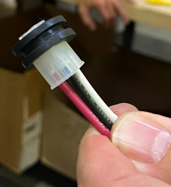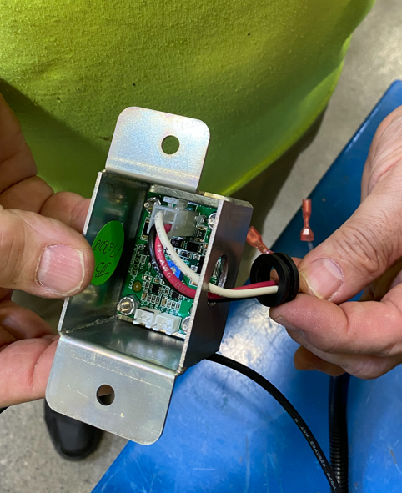
  - Take the wire from the probe on the feed line to the deck and pass it over top of the pump supply line as shown.

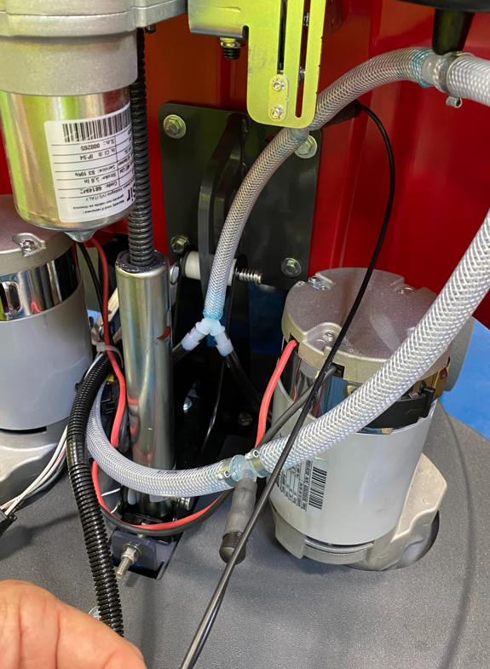

  - Feed the ends of the probe wires through the hole in the bottom of the TDS Board box. Connect the probes to the proper terminals. Ensure that the probe terminal with the black line is connected to the board terminal with the black line. Put the grommet back into the hole.
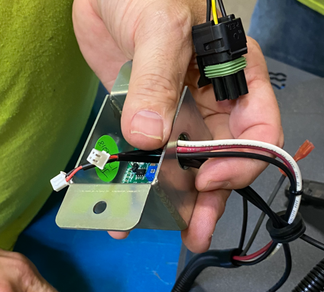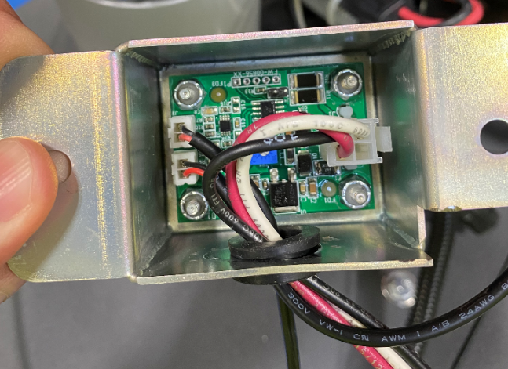

  - Cut about 12” of 3/8” loom (E11213) and wrap it around the bare wires at the ends of the harness going into the shield bracket. Feed the end of the loom through the grommet.
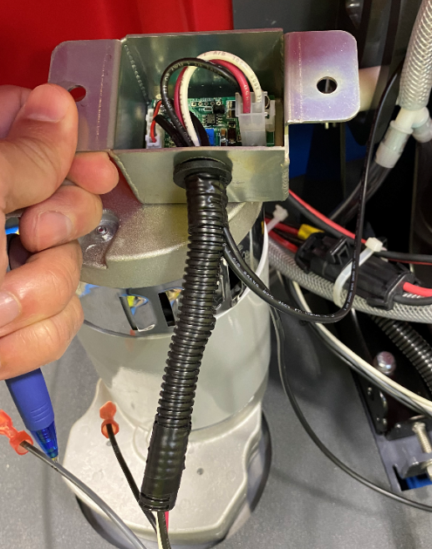

  - Mount the TDS Board to the inside of the head lift on the right side using 2 bolts (E29410) and 2 nuts (E28853).
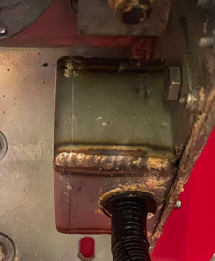
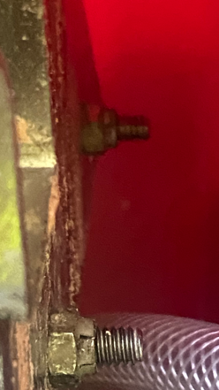

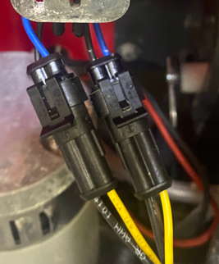
  - Connect the Low and Medium Pressure Switches to the appropriate terminals on the main wiring harness. (Assembler left side)
Medium Pressure – Purple wire from Harness
Low Pressure – Blue wire from Harness

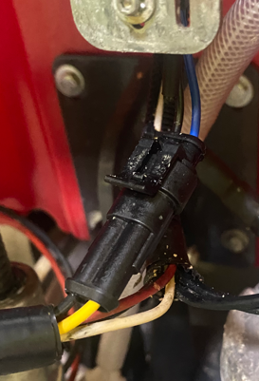
  - Connect the High-Pressure Switches to the appropriate terminals on the main harness. (Assembler right side)
Gray Wire from Harness

  - Be sure the harness passes in front of the actuator as shown.

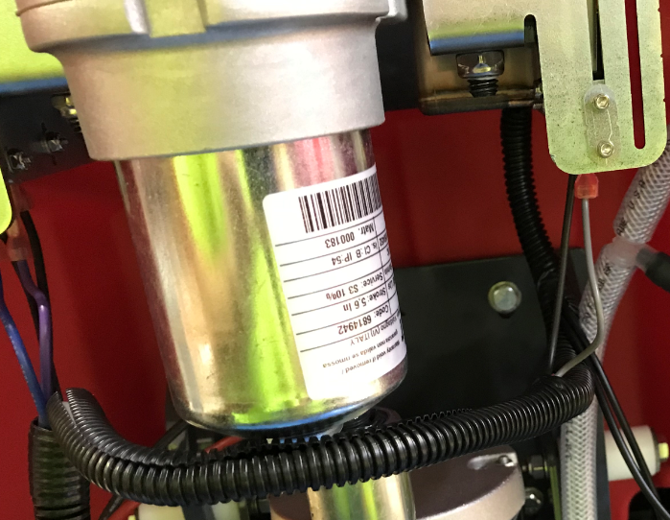

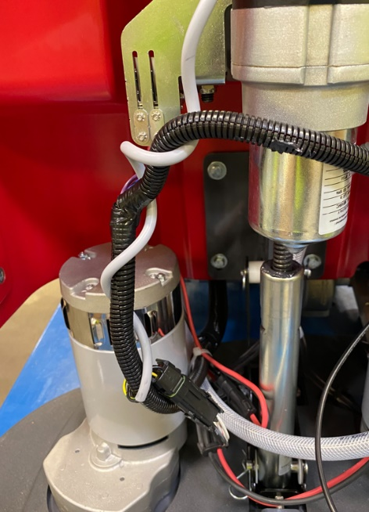
  - Disconnect the actuator from the power supply and connect it to the proper connector on the main harness. Wrap the actuator wire around the harness to keep it from moving around.

  - Make sure the machine is under power. Turn the key on and the deck should raise up. Ensure all of the cables and hoses are still resting properly.

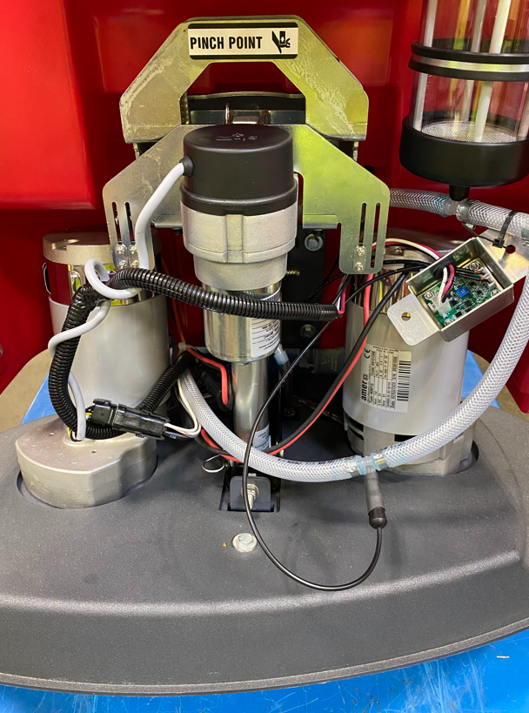

  - Wrap a skirt around the deck (E29341 for 26” / E29342 for 28” / E29343 for 32”). Adjust the tension so that it is loose enough to float up and down but tight enough so that it doesn’t fall off.

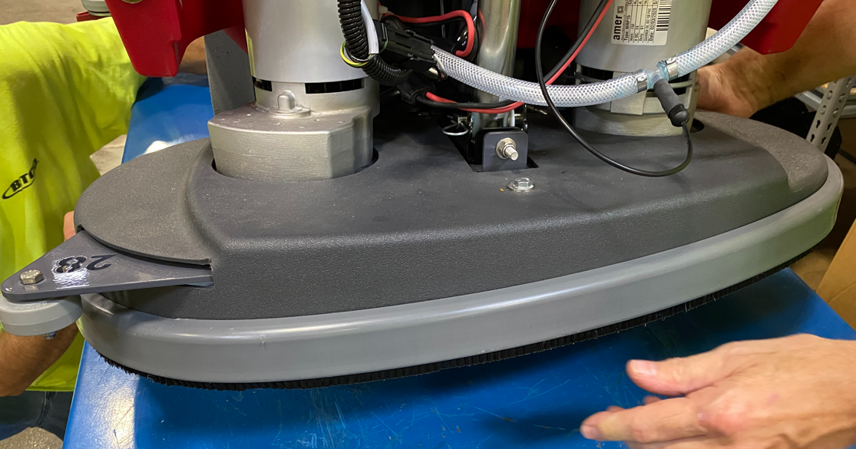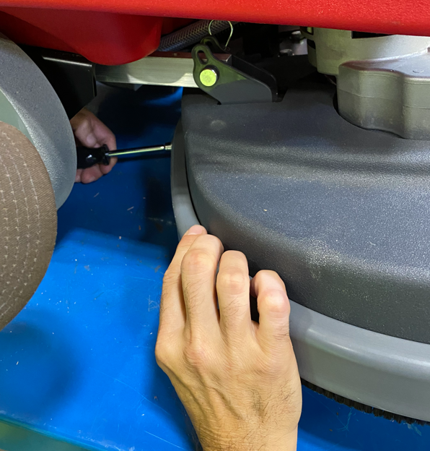

  - Refer to the appropriate SOP for instructions on how to assemble a Recovery Tank.
  - Place the tank near the machine using the cart shown. This will angle it to allow it to be attached easier. Bring the tank over to the machine and adjust the build cart height to allow the first hinge to be attached.

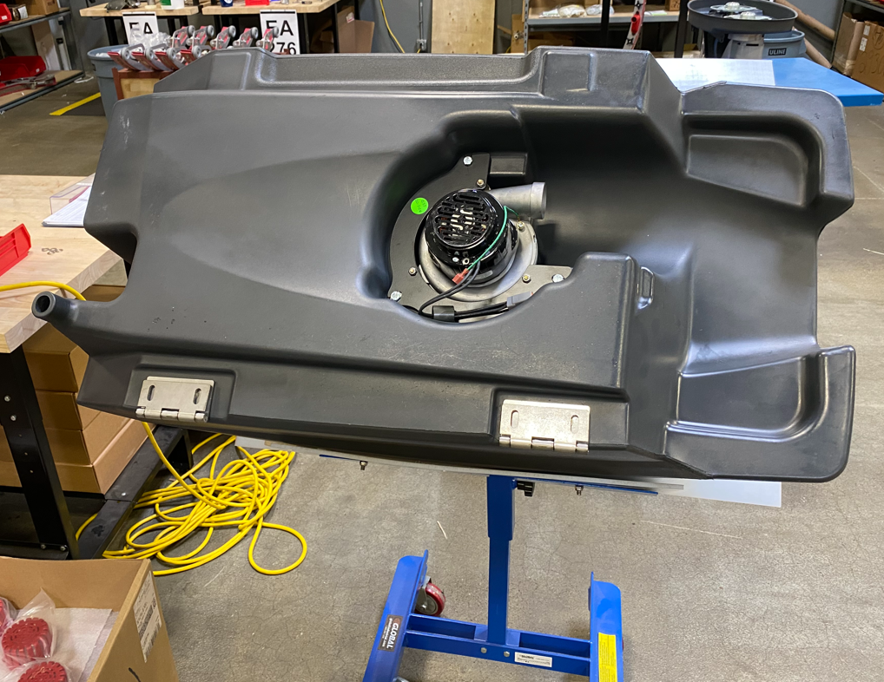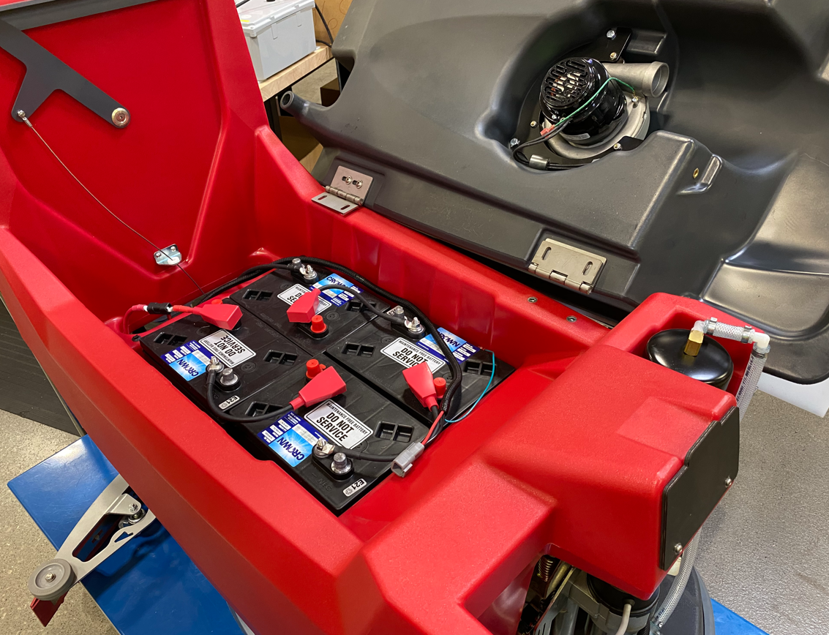

  - Attach the first hinge using 2 flange bolts (E29569). Once that is done, adjust the build cart height to allow the 2nd hinge to be attached. Use 2 more flange bolts (E29569) to attach.
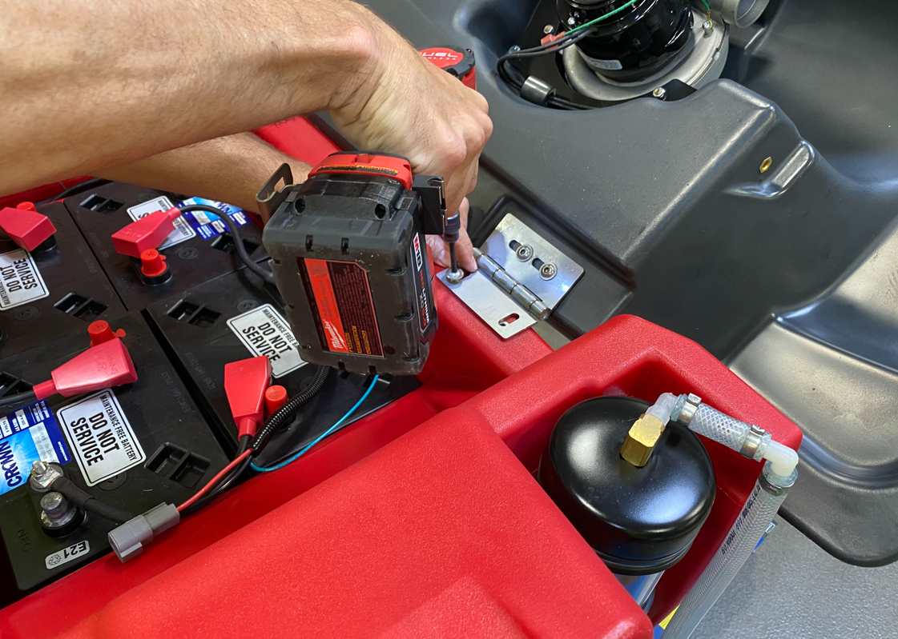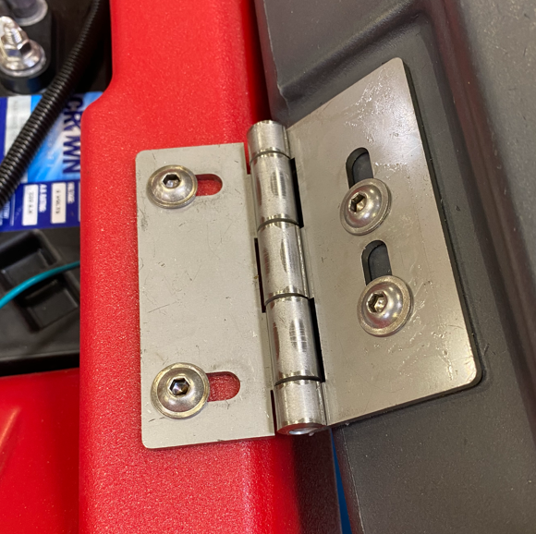
  - Close the recovery tank lid and verify that it is centered on the machine. If not, open it back up and readjust by loosening the screws and move it. Continue until it is centered. **There is nothing keeping the recovery tank from falling all the way open. Ensure either the cart is in place or there is another person helping hold it open if adjustment is needed.**

  - Attach the solution and recovery tanks using a recovery tank cable (E28760). Attach each end of the cable using a hex bolt (E29392) and a hex nut (E12524). Thread the bolt in part way, then tighten the nut to the tank to ensure the cable end can pivot. **Note-Ensure that the cable loops down into the solution tank cavity as the lid is closed. If it loops upward it could loop around the HEPA filter and tear if off. If it loops up, either put a kink in the cable or turn one of the ends of the cable 180°.
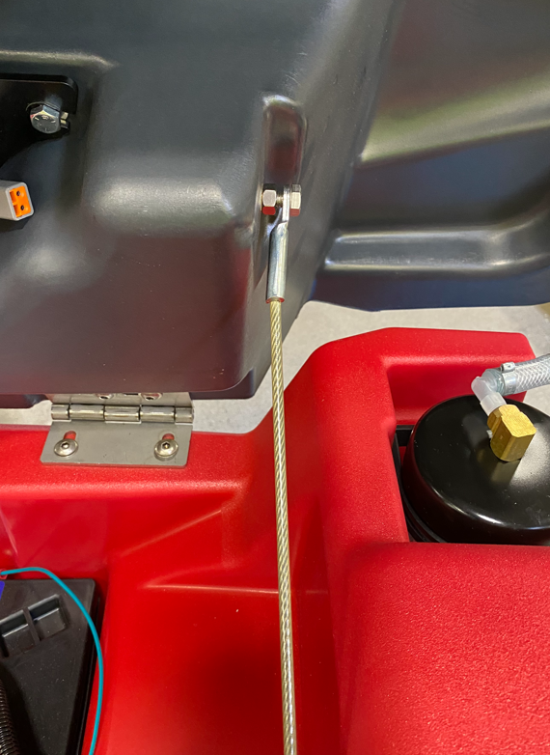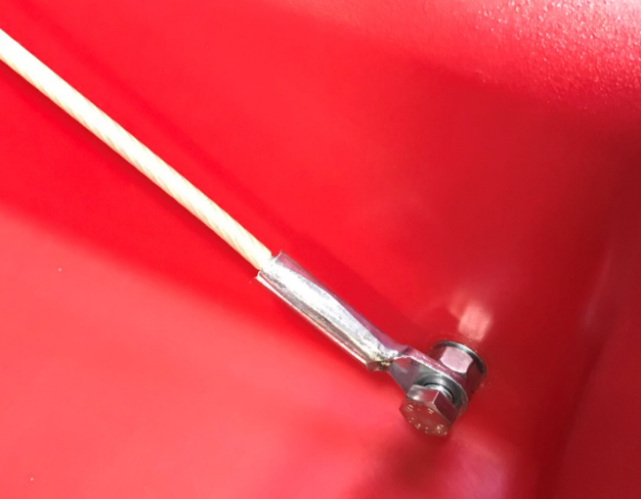
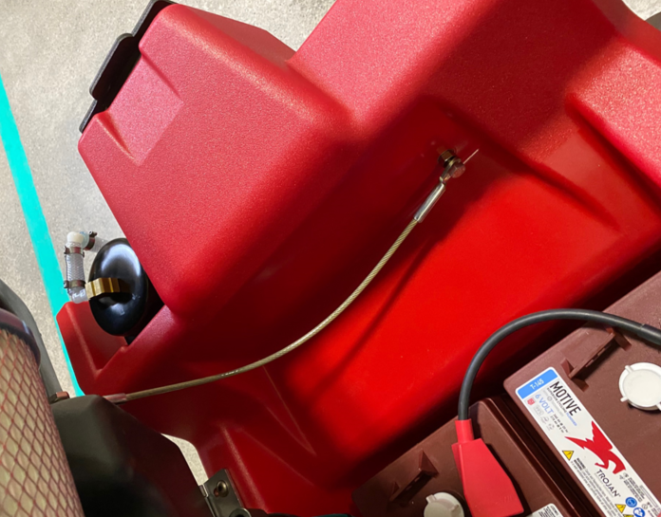

  - Install a HEPA filter (E29527) onto the vac motor using a worm clamp (E28755). Use the provided torque screwdriver to tighten the clamp to 15 in-lbs of torque.

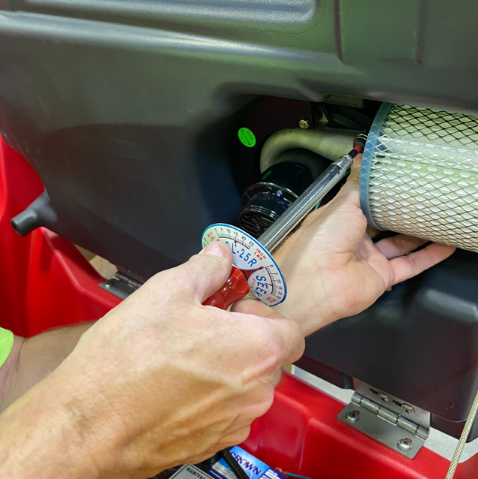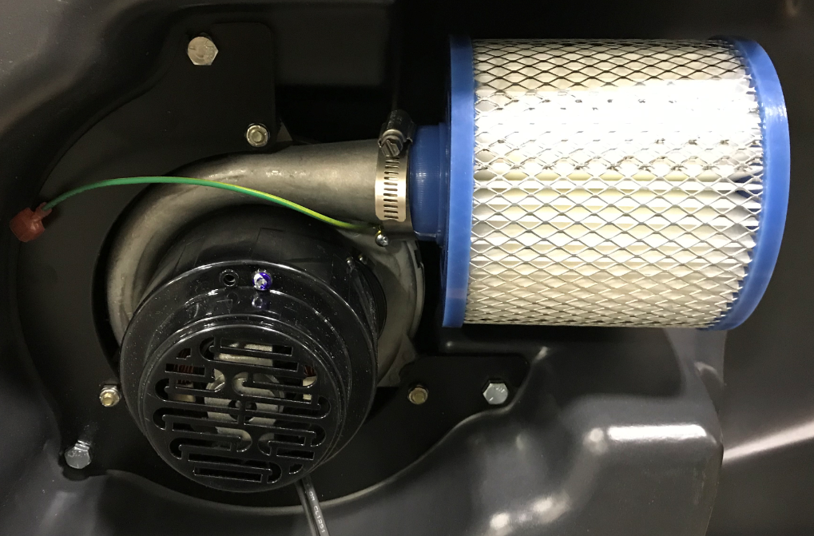

  - Connect the vac motor and the ground wires to the main wire harness. Clean up the wiring in the tank using 2 zip ties (E83523).

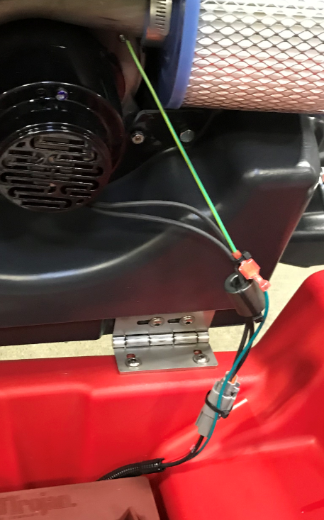

  - Clean up the wiring in the battery compartment. This step uses 3 zip ties (E83523).
Pass vac harness portion over zip tie mount and attach with a zip tie
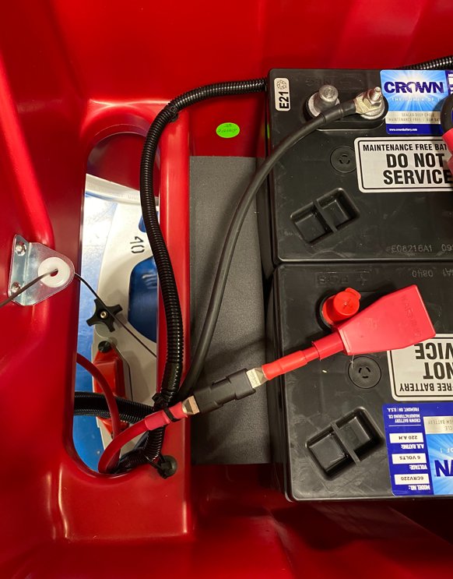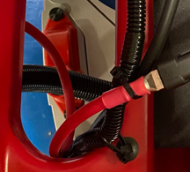
Bundle + wire, - wire, and harness here
Attach harness here
Position all cables near this zip mount

  - Take a squeegee vac hose (E29576) and press the angled end onto the barbed fitting on the back of the recovery tank.
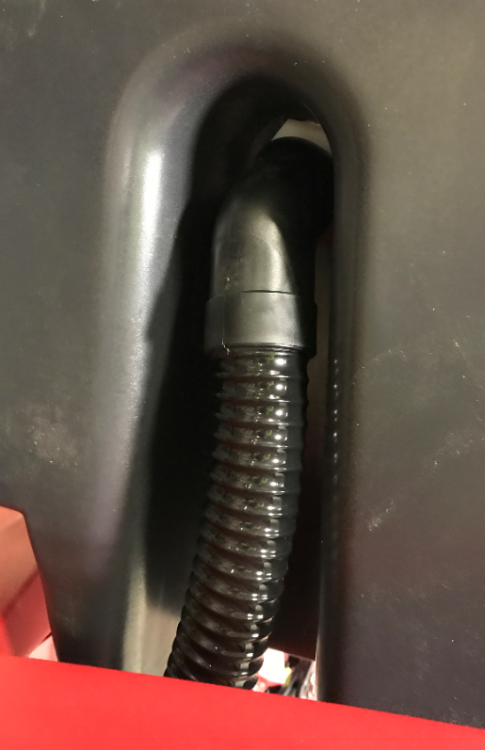
  - Take a recovery tank drain hose (E28921) and attach it into the drain port of the recovery tank by using a worm clamp (E83966).
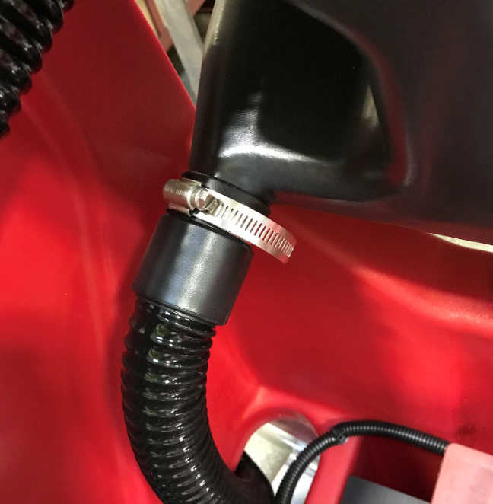
  - Route the 2 hoses out of the battery compartment.

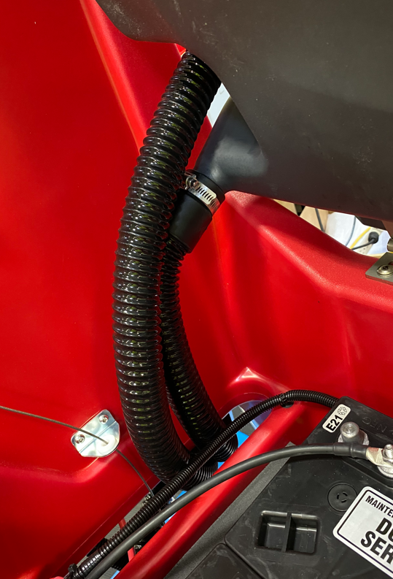

  - Connect the end of the squeegee vac hose to the port on the squeegee. Hang the end of the recovery tank drain hose as shown.

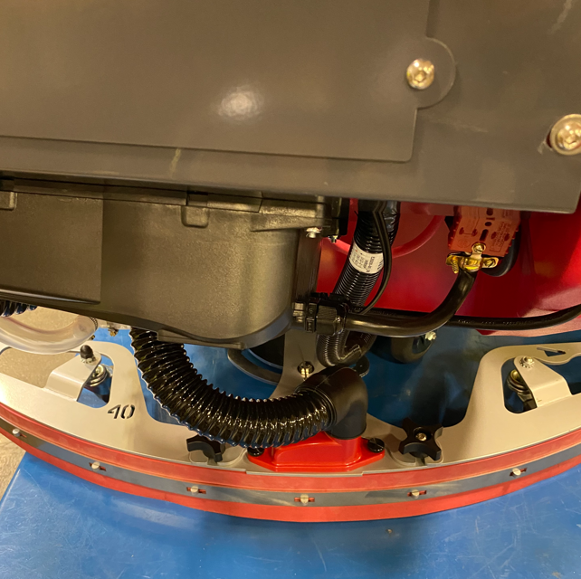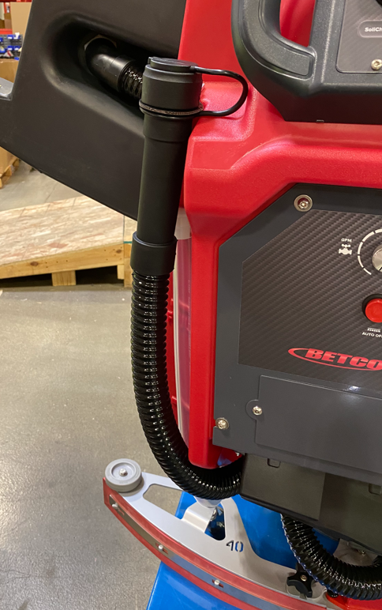

  - Take a recovery tank lid (E28577). Put a little blue silicone gasket maker into the groove in a couple points to hold the gasket in place. Be sure to put some under each end of the gasket. Cut a 7’ length of gasket (E29528) and install it into the groove. The edge with the rounded bulb goes towards the outside of the lid. Trim as needed to get the ends to line up.
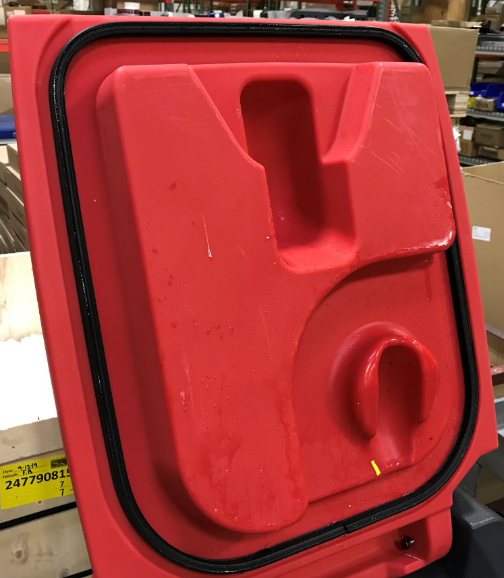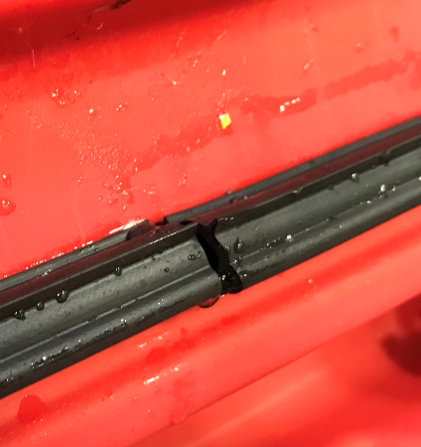
Ends meet here
  - Attach the lid to the tank using 2 shoulder bolts (E29558).

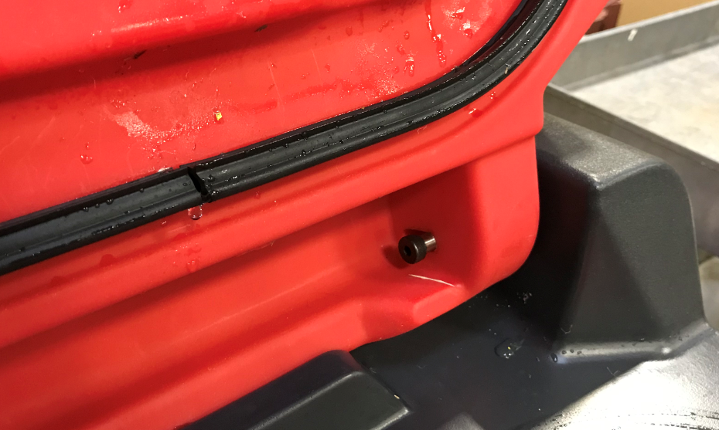

  - Attach a debris tray (E29525) to a puck holder (E29561) and place them into the pocket in the tank.

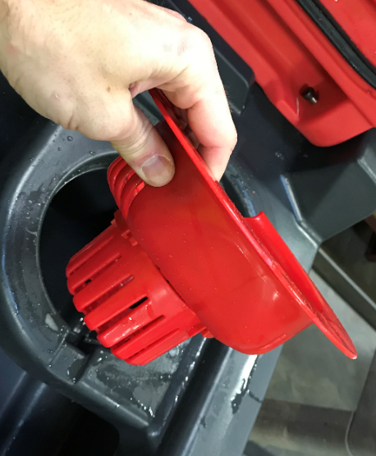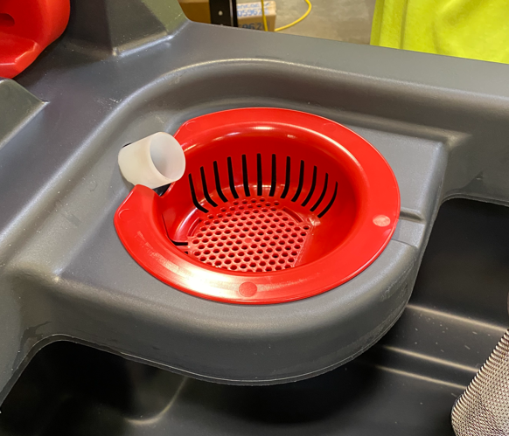

  - Close the recovery tank lid.
  - Do a quick functional check of the unit to make sure all of the functions work prior to sending the machine to QC.
    - Verify vac motor turns on and off as required.
    - Verify head lift goes up and down. The head lift switches are not yet set but moving the knob to down pressure 1 should start it moving down. Once you verify it moves down, turn the knob back to the UP position and it will retract.
    - Ensure the wheels are chocked and quickly check the transaxle. Turn the speed knob all the way down and pull the bail. You should feel the machine try to move.

- References (optional section as needed)

- Training Guide

Functional Training Groups Requiring Training
Equipment Assembly Group

- SOP Change Control

Date of Change | Reason for Change
Rev 01 | This is the first version of the S.O.P. hence there are no revisions to this document.
Rev 02 - 8/19/2021 | Updated process and moved all orbital and option info to another SOP.
Rev 03 - 10/26/2021 | Added puck cage installation and updated probe install sequence
Rev 04 - 11/15/2023 | Updated for TDS installation
Rev 05 - 5/13/2025 | Removed Bluetooth option and updated head lift support
Rev 06 – 1/20/2026 | Removed Armor and Timer Options. Added battery installation.

Approvals

Submitter/Author Approval:__________________________________ Date:______________________

Management Approval:______________________________________ Date:______________________

QAU Approval:_____________________________________________ Date:______________________

